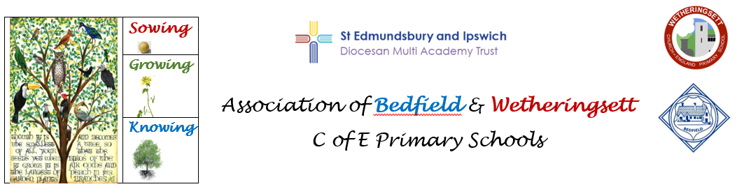

Three Big Ideas
Coding: Children understand logical thinking and use it to create algorithms and programs
Communication: Children know how to use information and communication technology to express and present ideas effectively
E-Safety: Children know how to use technology responsibly and know how to stay safe online.

Overview of Computing Planning KS1 (Cycle A)

 |   Autumn 1 | Autumn 2 |   Spring 1 | Spring 2 |   Summer 1 | Summer 2
Year 1/2 | Computing systems and networks.  Year 1 unit- Technology around us. | Creating Media Units- 4 units.  Year 1- Digital painting and Digital writing  Year 2 – Digital photography and Digital music.  Programming A Units-2 units.  Year 1- Moving robot  Year 2- Robot algorithms

Overview of Computing Planning KS1 (Cycle B)
 | Autumn 1 | Autumn 2 | Spring 1 | Spring 2 | Summer 1 | Summer 2
Year 1/2 | Computing systems and networks.  Year 2 Unit -IT around us | Data and information- 2 units.  Year 1- Grouping data  Year 2- Pictograms  Programming B Units- 3 units.  Year 1- Programming animations  Year 2- Programming quizzes  Extra Units:  One lesson on code a class mate from Twinkl  https://www.twinkl.co.uk/resource/code-a-classmate-activity-pack-cfe-i-2  - Writing cooking algorithms- see info below and link.  https://blog.codespark.com/posts/recipe-algorithm  Children can plan a recipe with given ingredients, write the ingredients needed and the algorithm and then try the recipe out. Is there anything they need to debug?

1 | Cooking with algorithms
Nothing motivates children more than getting to make their favourite snack, especially when they know they will get to enjoy it at the end. In school this could be making a smoothie or popcorn, linked to a restaurant or movie theme.
Algorithms are sequences of steps which need to be followed in a specific order to reach an end result and following a recipe is the perfect activity.
Throw in some challenges such as the following: if the smoothies are for group A, use kiwis and carrot juice; if they are for group B, use bananas. If we’ve run out of butter for the popcorn, what should we use instead?
‘If-then-else’ statements are conditional sequences of steps which are done only if the ‘if’ condition criteria are met. Furthermore, ‘debugging’ is a great way for children to determine why their smoothies are suddenly not tasting as planned.
They have to use their problem-solving skills to figure out that they have missed adding the bananas.

