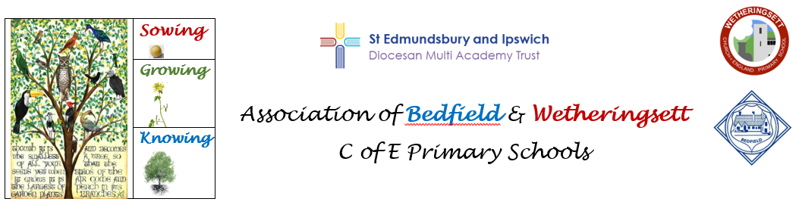

Three Big Ideas
Coding: Children understand logical thinking and use it to create algorithms and programs
Communication: Children know how to use information and communication technology to express and present ideas effectively
E-Safety: Children know how to use technology responsibly and know how to stay safe online.

Overview of Computing Planning KS2 (Cycle A)

 |   Autumn 1 | Autumn 2 |   Spring 1 | Spring 2 |   Summer 1 | Summer 2
Year 3/4 | Computing systems and networks.  Year 3 unit- connecting computers | Creating Media Units- 4 units.  Year 3- Stop frame animation and desktop publishing  Year 4 – Audio production and photo editing  Programming A Units-2 units.  Year 3- Sequencing sounds  Year 4- Repetition in shapes.
Year 5/6 | Computing systems and networks.  Year 5 Unit -Systems and searching | Creating Media Units- 4 units.  Year 5- Video production and introduction to vector graphics  Year 6 – Web page creation and 3D modelling  Programming A Units-2 units  Year 5- Selection in physical computing  Year 6- Variables in games.

Overview of Computing Planning KS2 (Cycle B)
 | Autumn 1 | Autumn 2 | Spring 1 | Spring 2 | Summer 1 | Summer 2
Year 3/4 | Computing systems and networks  Year 4 Unit- The internet | Data and information- 2 units.  Year 3- Branching databases  Year 4- Data logging  Programming B Units- 3 units.  Year 3-Events and actions in progress  Year 4- Repetition games  Extra Unit- Microbits- electrical conductors  https://microbit.org/teach/lessons/electrical-conductors-unit-of-work/  Choose a 2nd Microbit unit of your choice.
Year 5/6 | Computing systems and networks.  Year 6 unit-  Communication and collaboration | Data and information- 2 units.  Year 5-Flat file databases  Year 6- Introduction to spreadsheets.  Programming B Units- 3 units.  Year 5-Selection in quizzes  Year 6- Sensing movement  Extra Unit: Microbits- energy awareness  https://microbit.org/teach/lessons/energy-awareness/  Choose a 2nd Microbit unit of your choice.

