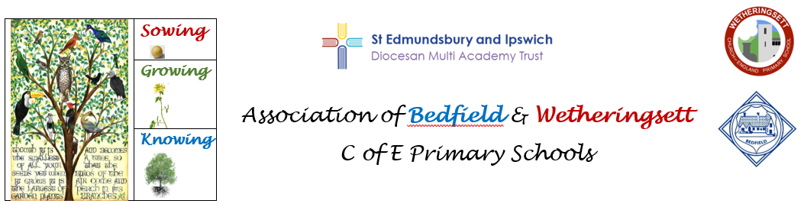
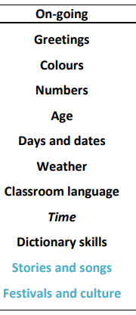
Our MFL teaching scheme is derived from T Davies’ work on teaching French for the MAT.
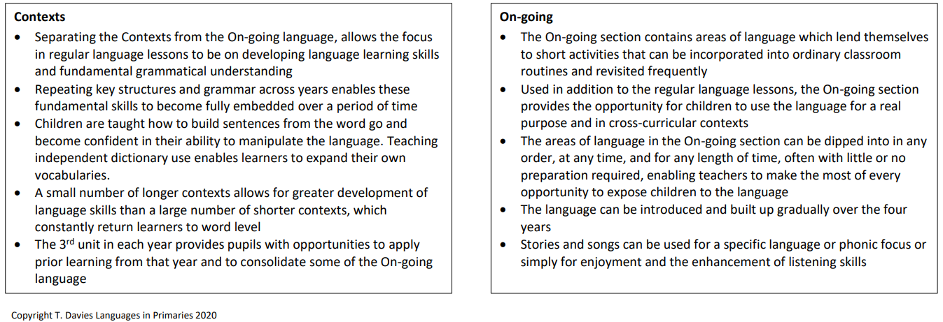
The Three Big Ideas
Culture: Children develop understanding of a different language and cultures, appreciating and respecting similarities and difference
Understanding: Children develop knowledge of spoken and written words in another language (French)
Fluency: Children become sufficiently fluent to listen and respond in another language (French)
Refer the children to maps of France/Paris to identify focus locations and urban/rural areas

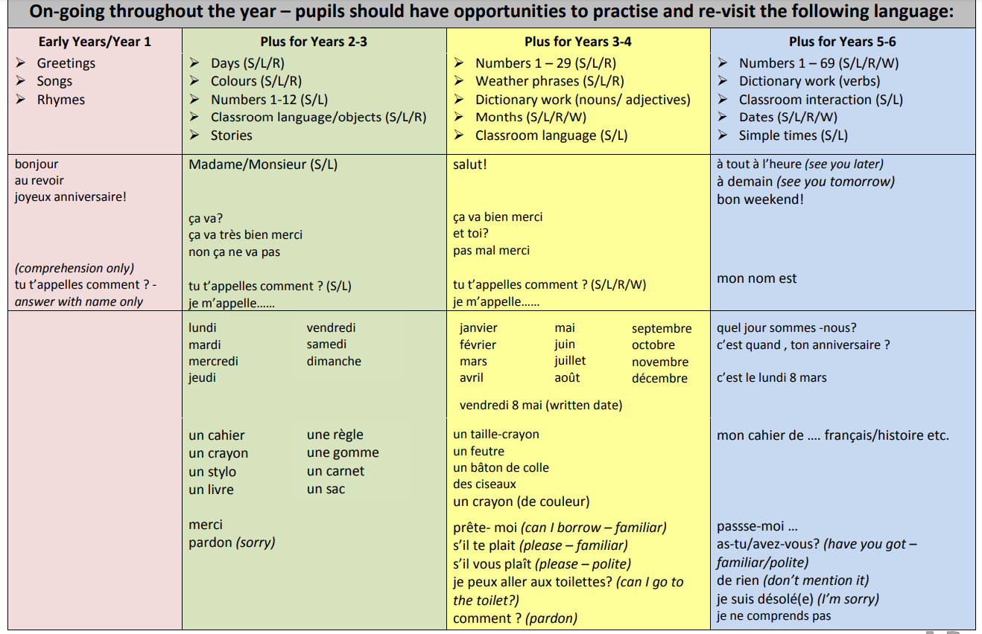

Cycle 1 (Green)  Each cycle runs through stages, each child starts with Stage 1 and progresses from there | Autumn   | Spring   | Summer  
Stage 1-2  EYFS/YRs 1& 2 | Unit 1  Des animaux au zoo  Children:  Culture  Look at and discuss pictures of Parc Zoologique de Paris  Begin to identify words in an authentic source  Understanding  Understand and write some animal nouns and adjectives in phrases/short sentences  Recognise the difference between masculine and feminine articles and begin to select correctly  Fluency  Begin to make some letter/sound links | Unit 2  Le pique-nique  Children:  Culture  Look at and discuss pictures of French Cafes  Begin to identify words in an authentic source  Understanding  Understand questions about food and drink likes and respond using opinion phrases and/or adjectives  Recognise the difference between masculine and feminine articles and begin to select correctly  Flency  Begin to make some sound-letter links | Unit 3  Moi et mes animaux  Children:  Culture  Look and discuss some pictures of Frech people and their pet dogs in public places  Begin to identify words in an authentic source  Understanding  Build and understand short sentences about pets  Understand some questions about personal details and respond with appropriate information, some in sentences  Recognise the difference between masculine and feminine articles and begin to select correctly  Fluency  Begin to make some sound-letter links
Stage 1-2  + Stage 2-3  Year 3/4 | Unit 1  Des animaux au zoo  Children:  Culture  Discuss pictures of Parc Zoologique de Paris and London Zoo  Identify a number of words and phrases in an authentic source  Understanding  Understand and write animal nouns with correctly placed adjectives in short sentences  Begin to build and understand some longer sentences with conjunctions  Understand, say and write plural sentences with numbers and animals  Understand that there are male and female articles and know ways to check which to use  Use a dictionary for nouns and adjectives (with support)  Recognise that a female noun requires an adjective to match  Fluency  Begin to apply phonic knowledge to support L/S/R/W | Unit 2  Le pique-nique  Children:  Culture  Discuss pictures of Cafes and restaurants in Paris to those in London  Identify a number of words and phrases in an authentic source  Understanding  Understand questions about food and drink likes and respond using opinion phrases and/or adjectives  Begin to build and understand some more complex sentences with appropriate conjunctions  Ask questions about food and drink likes  Understand that there are male and female articles and know ways to check which to use  Use a dictionary with support for nouns and adjectives  Fluency  Begin to apply phonic knowledge to support L/S/R/W | Unit 3  Moi et mes animaux  Children:  Culture  Discuss and compare pictures of Frech people and their pet dogs in public places  Identify a number of words and phrases in an authentic source  Understanding  Build and understand sentences giving details and other personal information  Understand questions about pets and other personal details and respond in sentences  Ask some questions about pets and other personal details  Understand there are masculine/feminine articles and know ways of checking which one to use  Use a dictionary with support for nouns  Fluency  Begin to apply phonic knowledge to support L/S/R/W
Stage 1-2  + Stage 2-3  Stage 3-4  Year 5/6 | Unit 1  Des animaux au zoo  Children:  Culture  Discuss and compare pictures of Parc Zoologique de Paris and London Zoo, noting similarities and differences  Independently identify a number of words/phrases in an authentic source and apply strategies to work out meaning  Understanding  Understand, say and write animal sentences applying knowledge of m/f/pl/adj placement and agreement  Build and understand longer and/or more complex singular, plural and negative sentences  Begin to understand how to use a negative phrase followed by a noun  Build and understand sentences using peut+ infinitive  Understand ‘infinitive’ in relation to verbs  Use a dictionary independently for nouns and adjectives and with support for infinitive of verbs  Fluency  Apply phonic knowledge to support L/S/R/W a new language | Unit 2  Le pique-nique  Children:  Culture  Discuss pictures of Cafes and restaurants in Paris to those in London  Independently identify a number of words/phrases in an authentic source and apply strategies to work out meaning  Understanding  Understand and ask a variety of questions about food and drink likes and dislikes  Build and understand longer and/or more complex sentences including some using the third person  Understand the term ‘infinitive’ in relation to verbs  Recognise patterns in -er conjugation  Use a dictionary independently for nouns and adjectives and with support for infinitive of verbs  Fluency  Independently identify a number of words/phrases in an authentic source and apply strategies to work out meaning  Apply phonic knowledge to support L/S/R/W including of new language | Unit 3  Moi et mes animaux  Children:  Culture  Discuss and compare pictures of people in Paris and London with their pet dogs in public places  Independently identify a number of words/phrases in an authentic source and apply strategies to work out meaning  Understanding  Build and understand a variety of sentences giving details about pets, personality and other personal details  Understand a variety of questions about pets and personal details and respond using a range of language  Ask a variety of questions about pets and personal details and respond using a range of language  Apply knowledge of masculine/feminine agreement of adjectives to sentences about personality  Begin to understand how to use a negative phrase followed by a noun  Use a dictionary independently for nouns  Fluency  Apply phonic knowledge to support L/S/R/W including of new language

Cycle 2 (Red)  Each cycle runs through stages each child starts with | Autumn | Spring | Summer
Stage 1-2  EYFS/YRs 1& 2 | Unit 1  Ici et la  Children:  Culture  Look at and discuss pictures of places in urban and rural France  Begin to identify words in an authentic source  Understanding  Understand questions about place likes and respond using opinion phrases and/or adjectives  Recognise the difference between masculine and feminine articles and begin to select correctly  Fluency  Begin to make some sound-letter links | Unit 2  A la mode  Children:  Culture  Look at and discuss pictures of French fashions for men and women  Begin to identify words in an authentic source  Understanding  Understand, say and write some clothes nouns and colour adjectives in phrases/short sentences  Recognise the difference between masculine and feminine articles and begin to select correctly  Fluency  Begin to make some letter sound links | Unit 3  Je pars en vacances  Children:  Culture  Look at and discuss pictures of children on camping holidays in France  Begin to identify words in an authentic source  Understanding  Build and understand short sentences about backpack contents  Understand some questions and personal details and respond with appropriate information, some in sentences  Recognise the difference between masculine and feminine articles and begin to select correctly  Fluency  Begin to make some letter sound links
Stage 1-2  + Stage 2-3  Year 3/4 | Unit 1  Ici et la  Children:  Culture  Look at and discuss pictures of places in urban and rural France  and compare them  Identify a number of words and phrases in an authentic source  Understanding  Understand questions about place likes and respond in sentences using opinion phrases and adjectives  Begin to build and understand more complex sentences with appropriate conjunctions  Ask questions about place likes  Understand why there are masculine and feminine articles and know ways of checking which one to use  Use a dictionary with support for nouns and adjectives  Fluency  Begin to apply phonic knowledge to support L/S/R/W | Unit 2  A la mode  Children:  Culture  Discuss pictures of French fashions for men and women and compare them  Identify a number of words and phrases in an authentic source  Understanding  Understand, say and write clothes nouns with correctly placed adjectives in short sentences  Begin to build and understand longer sentences using the third person  Understand there are masculine and feminine articles and know ways of checking which one to use  Recognise a feminine noun requires an adjective to match  Fluency  Begin to apply phonic knowledge to support L/S/R/W | Unit 3  Je pars en vacances  Children:  Culture  Discuss and compare pictures of children on camping holidays in France  Begin to identify words in an authentic source  Understanding  Build and understand sentences giving details about backpack contents and personal information  Understand questions about personal details and respond in sentences  Ask some questions about personal details  Understand there are masculine and feminine articles and know ways of checking which one to use  Use a dictionary with support for nouns  Fluency  Begin to apply phonic knowledge to support L/S/R/W
Stage 1-2  + Stage 2-3  Stage 3-4  Year 5/6 | Unit 1  Ici et la  Children:  Culture  Look at and discuss pictures of places in urban and rural France  and compare them to equivalent settings in Britain  Independently identify a number of words/phrases in an authentic source and apply strategies to work out meaning  Understanding  Understand questions about place likes and preferences respond using a range of language  Begin to build and understand longer and/or more complex sentences including some using the third person  Ask questions about place likes and preferences  Understand the term ‘infinitive’ in relation to verbs  Use a dictionary independently for nouns and adjectives and with support for infinitives of verbs  Fluency  Apply phonic knowledge to support L/S/R/W including of a new language | Unit 2  A la mode  Children:  Culture  Discuss pictures of French fashions for men and women and compare them, identifying similarities and differences  Independently identify a number of words/phrases in an authentic source and apply strategies to work out meaning  Understanding  Understand, say and write clothes sentences applying knowledge of m/f/pl/adj placement and agreement  Begin to build and understand longer and/or more complex singular, plural, negative and third person sentences  Understand the term ‘infinitive’ in relation to verbs  Recognise patterns in -er conjugation  Use a dictionary independently for nouns and adjectives  Fluency  Apply phonic knowledge to support L/R/S/W including of a new language | Unit 3  Je pars en vacances  Children:  Culture  Discuss and compare pictures of children on camping holidays in France and Britain  Independently identify a number of words/phrases in an authentic source and apply strategies to work out meaning  Understanding  Build and understand a variety of sentences giving details about backpack contents and personal details  Understand questions about backpack contents and respond using a range of language  Understand a variety od questions about personal details and respond using a range of language  Ask a variety of questions about backpack contents and personal details  Apply knowledge of masculine and feminine agreement of adjectives to sentences about the nationality of others  Begin to understand how to use a negative phrase followed by a noun  Use a dictionary independently for nouns  Fluency  Apply phonic knowledge to support L/R/S/W including of a new language

Cycle 2 (Blue)  Each cycle runs through stages each child starts with | Autumn | Spring | Summer
Stage 1-2  EYFS/YRs 1& 2 | Unit 1  Un monster aimable  Children:  Culture  Label body parts in French and English using pictures of people in French contexts  Begin to identify words in an authentic source  Understanding  Understand, say and write some body nouns and colour adjectives in phrases/short sentences  Recognise the difference between masculine and feminine articles and begin to select correctly  Fluency  Begin to make some letter- sound links | Unit 2  Une famille de super-heros  Children:  Culture  Label members of families of superheroes in French (The Incredibles)  Begin to identify words in an authentic source  Understanding  Understand, say and write some family nouns and adjectives in phrases/short sentences  Understand questions about superhero likes and respond to opinion phrases  Recognise the difference between masculine and feminine articles and begin to select correctly  Fluency  Begin to make some letter- sound links | Unit 3  Je suis super-heros/superheroine  Children:  Culture  Look at and discuss pictures of French cartoon superheroes Create and describe attributes in French, choosing from given list  Begin to identify words in an authentic source  Understanding  Build and understand short sentences about superhero attributes  Understand some questions about personal details and respond with appropriate information, some in sentences  Fluency  Begin to make some letter- sound links
Stage 1-2  + Stage 2-3  Year 3/4 | Unit 1  Un monster aimable  Children:  Culture  Label body parts of monsters in French  Identify words and phrases in an authentic source  Understanding  Understand, say and write monster sentences applying knowledge of m/f/pl adj placement and agreement  Begin to build and understand longer and/or more complex singular, plural and negative sentences  Begin to understand how to use a negative phrase followed by a noun  Begin to use the third person to replace nouns in sentences  Build and understand sentences using pour+ infinitive  Understand the term ‘infinitive’ in relation to verbs  Use a dictionary independently for nouns and adjectives with support for infinitive of verbs  Fluency  Begin to apply phonic knowledge to support L/S/R/W | Unit 2  Une famille de super-heros  Children:  Culture  Label members of families of superheroes in French (The Incredibles) and their costumes  Identify a number of words and phrases in an authentic source  Understanding  Understand, say and write short sentences using family nouns  Understand, say and write short sentences using adjectives and masculine/feminine pronouns  Understand questions about superhero likes and respond in sentences using opinion phrases  Ask questions about superhero likes  Begin to build and understand some longer sentences with conjunctions  Understand there are masculine and feminine articles and know ways of checking which one to use  Use a dictionary with support for nouns  Fluency  Begin to apply phonic knowledge to support L/S/R/W | Unit 3  Je suis super-heros/superheroine  Children:  Culture  Discuss and compare pictures of French cartoon superheroes Create and describe attributes in French, choosing from given list  Identify a number of words and phrases in an authentic source  Understanding  Build and understand sentences giving details about and describing a superhero persona  Understand questions about superhero attributes and details and respond in sentences  Ask some questions about the personal details of a superhero persona  Use a dictionary with support for adjectives  Fluency  Begin to apply phonic knowledge to support L/S/R/W
Stage 1-2  + Stage 2-3  Stage 3-4  Year 5/6 | Unit 1  Un monster aimable  Children:  Culture  Label body parts in French using pictures of people in French contexts adding adjectives  Identify a number of words and phrases in an authentic source and apply strategies to work out meaning  Understanding  Understand, say and write body nouns with correctly placed adjectives in short sentences  Begin to build and understand some longer sentences with conjunctions  Understand, say and write plural sentences with numbers and body nouns  Understand that there are masculine and feminine articles and know ways of checking which one to use  Use a dictionary with support for nouns  Recognise that a feminine noun requires the adjective to match  Fluency  Begin to apply phonic knowledge to support L/S/R/W | Unit 2  Une famille de super-heros  Children:  Culture  Label members of families of superheroes in French (The Incredibles) and their costumes and setting  Independently identify a number of words and phrases in an authentic source and apply strategies to work out meaning  Understanding  Build and understand sentences about family, including some using a negative or third person information  Build and understand longer and/or complex sentences using m/f pronouns and adj agreement  Begin to understand how to use a negative phrase followed by a noun  Understand a variety of questions about superhero likes and respond using a range of language  Ask a variety of questions about superhero likes  Recognise patterns in _er verb conjugation  Use a dictionary independently for nouns and with support for infinitives of verbs  Fluency  Apply phonic knowledge to support L/S/R/W including of a new language | Unit 3  Je suis super-heros/superheroine  Children:  Culture  Discuss and compare pictures of French and American cartoon superheroes Create and describe attributes in French, choosing from given list  Independently identify a number of words/phrases in an authentic source and apply strategies to work out meaning  Understanding  Build and understand a variety of sentences giving details about and describing a superhero persona  Understand questions about superhero attributes and personal details and respond using a range of language  Ask a variety of questions about a superhero persona including description and personal details  Apply knowledge of masc/fem agreement of adjectives to sentences describing a superhero persona  Use a negative phrase  Use a dictionary independently for adjectives  Fluency  Apply phonic knowledge to support L/S/R/W including of a new language

Cycle 2 (Pink)  Each cycle runs through stages each child starts with | Autumn | Spring | Summer
Stage 1-2  EYFS/YRs 1& 2 | Unit 1  Mes activities de loisir  Children:  Culture  Look at and discuss pictures of children and families engaged in leisure activities in France  Begin to identify words in an authentic source  Understanding  Fluency  Begin to make some letter-sound links | Unit 2  Au parc d’attractions  Children:  Culture  Look at and discuss pictures of children at amusement parks in France  Begin to identify words in an authentic source  Understanding  Fluency  Begin to make some letter-sound links | Unit 3  Je suis athlete, je suis artiste  Children:  Culture  Look at and discuss a selection of pictures of French artistes/sportspeople/celebrities and identify favourites  Begin to identify words in an authentic source  Understanding  Fluency  Begin to make some letter-sound links
Stage 1-2  + Stage 2-3  Year 3/4 | Unit 1  Mes activities de loisir  Children:  Culture  Discuss and compare pictures of children and families engaged in leisure activities in France  Identify a number of words and phrases in an authentic source  Understanding  Understand questions about leisure likes and respond in sentences using opinion phrases and adjectives  Begin to build and understand some more complex sentences with appropriate conjunctions  Ask questions about leisure likes  Understand that there are masculine and feminine articles and know ways of checking which one to use  Use a dictionary with support for nouns and adjectives  Fluency  Discuss and compare pictures of children and families engaged in leisure activities in France and the UK  Begin to apply phonic knowledge to support L/S/R/W | Unit 2  Au parc d’attractions  Children:  Culture  Discuss and compare pictures of children at amusement parks in France  Identify a number of words and phrases in an authentic source  Understanding  Understand, say and write leisure park nouns in short sentences  Understand , say and write short sentences using correctly placed adjectives  Begin to build and understand some longer sentences with conjunctions  Understand, say and write plural sentences with numbers and leisure park nouns  Understand that there are masc/fem articles and know ways of checking which one to use  Use a dictionary with support for nouns and adjectives  Recognise that a feminine noun requires the adjective to match  Fluency  Begin to apply phonic knowledge to support L/S/R/W | Unit 3  Je suis athlete, je suis artiste  Children:  Culture  Discuss and compare a selection of pictures of French artistes/sportspeople/celebrities and identify favourites  Identify a number of words and phrases in an authentic source  Understanding  Build and understand sentences giving personal details in the persona of a sportsperson/dancer/artist etc  Understand questions about personal details and respond in sentences  As some questions about personal details  Understand there are masculine and feminine variations of many professions and know ways of checking in order to select correctly  Use a dictionary with support for professional nouns  Fluency  Begin to apply phonic knowledge to support L/S/R/W
Stage 1-2  + Stage 2-3  Stage 3-4  Year 5/6 | Unit 1  Mes activities de loisir  Children:  Culture  Discuss and compare pictures of children and families engaged in leisure activities in France and the UK  Independently identify a number of words/phrases in an authentic source and apply strategies to work out meaning  Understanding  Understand questions about leisure likes and preferences and respond using a range of language  Build and understand longer and/or more complex sentences including some in the third person  Ask questions about leisure likes and preferences  Understand the term ‘infinitive’ in relation to verbs  Use a dictionary independently for nouns and adjectives with support with the infinitives of verbs  Fluency  Apply phonic knowledge to support L/S/R/W including of new language | Unit 2  Au parc d’attractions  Children:  Culture  Discuss and compare pictures of children at amusement parks in France and the UK  Independently identify a number of words/phrases in an authentic source and apply strategies to work out meaning  Understanding  Understand, say and write longer and/or more complex singular, plural and negative leisure park sentences  Understand, say and write sentences applying knowledge of m/f adjective placement and agreement  Build and understand sentences using the second and third person  Begin to understand how to use a negative phrase followed by a noun  Understand the term ‘infinitive’ in relation to verbs  Recognise patterns in -er verb conjugation  Use a dictionary independently for nouns and adjectives with support for the infinitives of verbs  Fluency  Apply phonic knowledge to support L/S/R/W including of new language | Unit 3  Je suis athlete, je suis artiste  Children:  Culture  Discuss and compare a selection of pictures of French and British artistes/sportspeople/celebrities and identify favourites, giving reasons for selections  Independently identify a number of words/phrases in an authentic source and apply strategies to work out meaning  Understanding  Build and understand a variety of sentences giving personal details as a sportsperson/artiste/dancer etc  Understand questions about personal details and respond using a range of language  Ask a variety of questions about personal details  Apply knowledge of a range of m/f variations of professions  Apply knowledge of m/f agreement of adjectives to sentences giving nationality  Use a dictionary independently for professional nouns  Fluency  Apply phonic knowledge to support L/S/R/W including of new language

