Literacy | Maths
Key Stage 1:  Literacy including guided reading, writing, spelling and punctuation and grammar will be taught through a range of different genres and texts throughout the year. We will work on a five-step approach of: plan it, draft it, revise it, edit it and publish it. This allows the children to see that writing is a process and we can support them through each stage of it to reflect the features expected in the different kinds of writing they need to produce.  Reception:  We will be learning to write names, mark making and letter formations. We will be sequencing story events and understanding how a story is structured. All this will be planned through topics such as Houses and Homes, Farming and Harvest, and Journeys. The children will explore different books linked to these topics too.  The children will sing Nursery Rhymes and build their vocabulary through circle times. Encouraging lots of speaking and listening through games and activities. | Key Stage 1:  The children will be exploring, using resources to support  - Number and place value  - Addition and subtraction  - Shape  Reception:  - Number and place value to 5  - Addition and subtraction  - Sorting groups/ Comparing groups  - 1 more 1 less  - Writing numbers  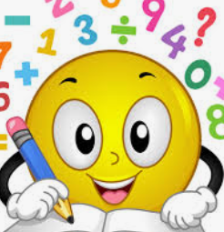
Science | History/Geography
Key Stage 1:  Autumn 1: Plants.  We will be finding out about different plants we eat and don’t eat. They will investigate the rate of plant growth and be able to name parts and explain food chains and transfer of energy.  Autumn 2: Living Things and their Habitats.  We will be investigating different habitats and what is needed to survive. The children will be exploring microhabitats and creating their own.  Reception (Understanding the World): Our Body  The children will have opportunities to discuss food, exercise and what keeps us healthy. The children will also find out about fruit and vegetables. They will learn about the life cycle of a chicken, linking to their own knowledge on how humans grow and change.  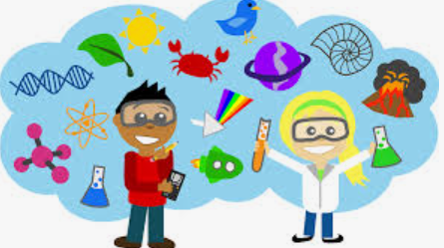 | Key Stage 1:  Autumn 1 - History: Family History.  We will be stepping back in time to think about how our grandparent lived when they were small. What the world looked like and the experiences they had. We will be looking at items from the past and comparing with what we have today.  Reception (Understanding the World):  The children will be learning about the lives of other people and society. They will have plenty of opportunity to discuss their life and the people that are important to them.  Key Stage 1:  Autumn 2 - Geography: People and their Communities.  We will be exploring what it is like where we live and identify key features of the local area. We will be comparing our lives in the UK to other places around the world.  Reception (Understanding the World):  We will be exploring the natural environment, making observations of the natural world and discuss contrasting environments in different places around the world. The children will discuss animals that live in different parts of the world.
Art/D.T. | Computing
Autumn 1: (Art)  Key Stage 1:Painting  We will be exploring and learning through the work of Wassily Kandinsky and Anthony Frost. The children will discuss their art work and recreate their own in a similar style. They will learn about primary colours, how to make secondary colours and create their own tints by adding white.  Autumn 2: (D.T.)  Key Stage 1:  The children will learn about cooking, food and nutrition. Exploring food from other countries. Designing their own recipe, making sure its colourful, tasty and healthy.  Reception (Expressive Arts and Design):  The children will have the opportunity to explore a variety of materials, tools and techniques, experimenting with colour form and function. They will have the opportunity to share their creations, explaining the process they have used.  The children with have the opportunity to design and make their own fire engine. | Key stage 1:  Autumn 1: Computer Systems and Networks  The children will find out about technology in school, the world and the benefits of IT. They will learn how to stay safe online and how to use IT appropriately.  Autumn 2: Grouping Data  We will be exploring how to label, match and group data. They will learn how to interpret groups and answer questions on what they can see.  Reception (Understanding the World):  The children will have the opportunity to use computers, Beebots and tablets with adult support in focus groups.  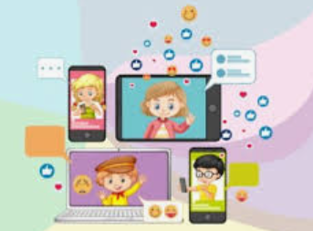
Music | R.E.
Key Stage 1 and Reception:  The children will be exploring different songs, rhymes and instruments. They will have opportunities to move to music to show and pitch with moving actions.   | Key Stage 1:  Autumn 1: Judaism- Believing.  Children will learn why forgiveness is important. How Jewish people pray and repent. We will explore special items that Jewish people use as part of their ceremonies such a Shofar.  Autumn 2: Christianity- Believing.  Children will discuss characters in the nativity and how they might feel. They will think about the Christmas story and learn about Angel Gabriel. Reflecting upon why Jesus is known as the Saviour.  Reception:  Children will learn why the word God is important to Christians and why Christians perform nativity plays.  We will also explore Muslim stories.
Little Wandle | P.S.H.E.
Key Stage 1:  We will be recapping old graphemes and learning new. We will be using these in writing and reading. We will apply our phonics knowledge to every area of the curriculum.  Reception:  The children will be learning new graphemes, learning how to write and read them in words. The children will gradually build up segmenting and blending with the graphemes they know.  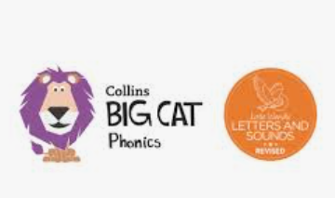 | Key Stage 1: Relationships  Children will learn about families and friendships. They will look at ways of making and maintaining positive and safe friendships. Safe relationships, managing secrets, resisting pressure and recognising hurtful behaviour. They will also consider how to ask for help and who their trusted adults are.  Reception (Personal Social and Emotional Development, Self-Regulation ELG):  The children will develop these skills every day through following instructions, understanding school rules, sharing, regulating their emotions and experiencing for new situations and experiences.

