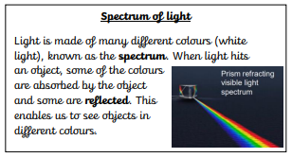
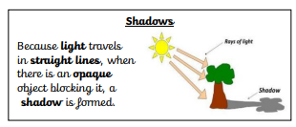
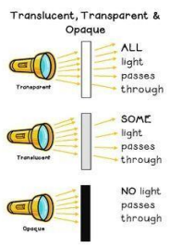
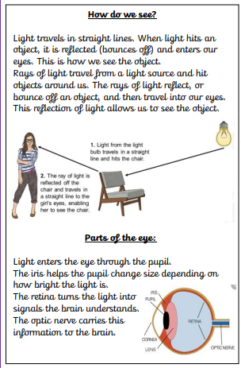
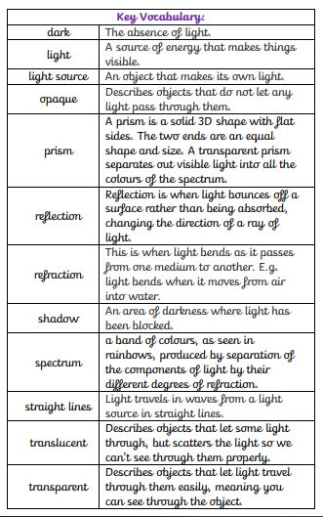
Science Knowledge Organiser- Light- Year 6 Unit
Curiosity:
I can explore and identify how light travels
I can explore and identify how light is reflected and enables us to see
Investigation:
I can investigate how and why shadows change
I know and can investigate how and why shadows are the same shape as the object that casts them
Explanation:
I know and can explain how shadows take shape and change
I know and can explain how light travels and enables us to see

