Word | Definition
Remembrance | The action of remembering the dead.
Armistice | A formal agreement of warring parties to stop fighting.
Evacuation | The action of leaving a person or place.
Persecution | Treating someone badly because of their race, ethnicity or religion.
Assassination | Murder for political or religious reasons.
VE Day | Victory in Europe Day.
Trenches | A long, narrow ditch
Trench Warfare | To attack, counterattack and defend from trenches.
Conflict | A serious disagreement or argument.
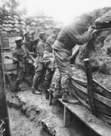
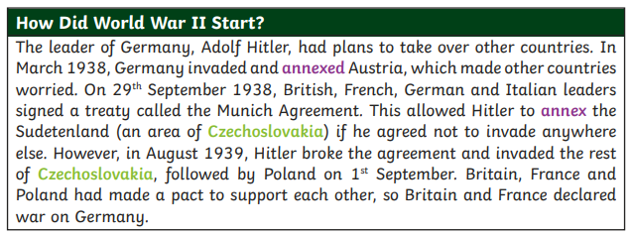
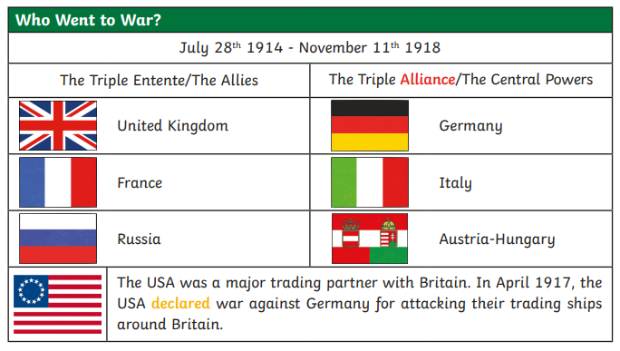
History Knowledge Organiser- The Impact of War. Did WW1 or WW2 have the biggest impact on our locality?

Chronology
I know the dates of key events in the start of World War I - the assassination of Franz Ferdinand leading to war being declared.
I know the dates of events leading to the involvement of other countries around the world.
I know the date of Armistice and subsequent Remembrance Sundays (11th day, 11th month - November 1918.)
I know key events from World War II and can sequence them with dates (When Neville Chamberlain declared War on Germany, dates other countries joined the War and events which preceded this, the Battle of Britain, VE Day on 8/5/1945.)
Equality
I know about circumstances relating to enlistment, and which soldiers were in the trenches/on the front line.
I know about people who were persecuted by Adolf Hitler.
I know about evacuation and why some people had to leave their homes.
I know about the changing role of women after World War II.
Change
I know about and can describe changes that have occurred in Britain between and after the Wars.

