

Bedfield and Wetheringsett CE Primary Schools

Child Protection and Safeguarding Policy
2026-2027

Prepared by: | Imogen Wallis
Approved by: | Governing body
Signature of Chair of Governors:

Status & review cycle | Statutory Annual
Date approved: | September 2026
Review date: | September 2027

Safeguarding Team Contacts at Bedfield and Wetheringsett

Role: | Name and contact details:
Designated Safeguarding Lead (DSL) | Imogen Wallis
Alternate DSL(s) | Bedfield – Vicki Langford and Carly Holland  Wetheringsett – Natalie Diwan and Emma Morris
Named safeguarding governor | Alice Palmer
Chair of Governors | Janine Wright
School online safety Lead | Bedfield – Imogen Wallis  Wetheringsett – Natalie Diwan
Designated teacher for Children in Care and children previously in care (CiC) | Imogen Wallis
Prevent Lead | Bedfield – Imogen Wallis  Wetheringsett – Natalie Diwan
Table of Contents

- Ethos statement

- Introduction

- Statutory framework

- Key roles and responsibilities

- Induction & Training

- Recognising concerns – signs and indicators of abuse

- Specific safeguarding issues

- Children potentially at greater risk of harm

- Opportunities to teach Safeguarding

- Online safety and filtering & monitoring

- Procedures

- Information sharing, record keeping and confidentiality

- Safeguarding concerns or allegations made about teachers, including supply teachers, other staff, volunteers and contractors.

- Use of school premises for non-school activities

- Whistleblowing

- Useful contacts and links

- Appendix A – recording form for safeguarding concerns or guidance for raising concerns on school’s safeguarding management system further information on specific safeguarding issues

- Appendix B – body map

School Child Protection and Safeguarding Policy Framework
Safeguarding and promoting the welfare of children is everyone’s responsibility. ‘Children’ includes everyone under the age of 18. Everyone who comes into contact with children and their families has a role to play. In order to fulfil this responsibility effectively, all practitioners should make sure their approach is child centred. This means that they should consider, at all times, what is in the best interest of the child.
(KCSiE 2026)

Ethos statement
We recognise the moral and statutory responsibility placed on all staff to safeguard and promote the welfare of all children. We aim to provide a safe and welcoming environment in which children can learn, underpinned by a culture of openness where both children and adults feel secure, are able to raise concerns and believe they are being listened to, and that appropriate action will be taken to keep them safe.

Introduction
The governing body/proprietor recognises the need to ensure that it complies with its duties under legislation and this policy has regard to statutory guidance, (KCSiE) 2026, Working Together to Safeguard Children 2026 and locally agreed inter-agency procedures put in place by Suffolk Safeguarding Partnership.

This policy will be reviewed annually, as a minimum, and will be made available publicly via the school website or on request.

Safeguarding and promoting the welfare of children is defined as: providing help and support to meet the needs of children as soon as problems emerge, protecting children from maltreatment whether that is within or outside the home, including online; preventing impairment of children’s mental and physical health or development; ensuring that children grow up in circumstances consistent with the provision of safe and effective care; and taking action to enable all children to have the best outcomes. (Working together to safeguard children 2026)

This policy is for all staff, parents, governors, volunteers, supply staff and contractors and the wider school community. It forms part of the child protection and safeguarding arrangements for our school and is one of a suite of policies and procedures which encompass the safeguarding responsibilities of the school (school to include appendix detailing school specific linked policies and procedures). In particular, this policy should be read in conjunction with the school’s Code of Conduct/Staff Behaviour Policy (including Acceptable Use of ICT), Prevent, Safer Recruitment Policy, Online Safety Policy, Behaviour and Anti-Bullying Policy, school’s guidance on low-level concerns, Child-on-Child Abuse Policy and procedures, and Part Five of KCSiE 2026, copies of which will be provided to all staff on induction.

The aims of this policy are to:

- Provide staff with a framework to promote and safeguard the wellbeing of children and young people and ensure that all staff understand and meet their statutory responsibilities.
- Ensure consistent good practice across the school.

The governing body/proprietor expects that all staff will have read and understand this child protection and safeguarding policy and their responsibility to implement it. All staff must as a minimum have read and understood Part One and annex A of KCSiE 2026 Governors/the proprietor will ensure that they and senior leaders have read and understand Parts One and Two of KCSiE 2026 as a minimum. Designated safeguarding leads, and any alternates, together with the headteacher (if not a member of the designated safeguarding lead team), will read the whole document. There may be some staff whom the governing body/proprietor require they read additional sections.

The governing body/proprietor will ensure that arrangements are in place for all staff members to receive appropriate safeguarding and child protection training which is regularly updated. The governing body/proprietor will ensure that all governors and trustees receive appropriate safeguarding and child protection training (including online) at induction which is regularly updated.

Compliance with the policy will be monitored by the Headteacher, designated safeguarding lead (DSL) and named safeguarding governor/proprietor.

Statutory framework
Section 175 of the Education Act 2002 (as amended) in the case of maintained schools and pupil referral units, Section 157 of the Education Act 2002 (as amended) and the Education (Independent School Standards) Regulations 2014 for independent schools (including academies and free schools), the Non-Maintained Special Schools (England) Regulations 2015, and the Apprenticeships, Skills, Children and Learning Act 2009 (as amended) for post 16 education providers, place a statutory duty on governing bodies and proprietors to have policies and procedures in place that safeguard and promote the welfare of children and young people who are pupils of the school which must have regard to any guidance given by the Secretary of State.
In accordance with statutory guidance, Working together to safeguard children 2026, local safeguarding arrangements must be established for every local authority area by the three safeguarding partners (Local Authority, Police and Integrated Care Boards). All three partners have joint and equal duty for a range of roles and statutory functions including developing local safeguarding policy and procedures and scrutinising local arrangements.
In Suffolk, all schools have been named by the Suffolk Safeguarding Partnership (SSP) as relevant agencies. Schools must work in accordance with the multi-agency safeguarding arrangements and procedures developed by the SSP, which can be found on the SSP website: Suffolk Safeguarding Partnership (SSP).
The Children’s Wellbeing and Schools Act 2026 strengthens the role of education within multi-agency safeguarding arrangements. It places requirements on safeguarding partners to include education agencies in local safeguarding arrangements, supporting education to play an active role in the safeguarding and protection of children.

Key roles and responsibilities
Governing Body/Proprietor
The governing body/proprietor has a strategic leadership responsibility for the school’s safeguarding arrangements and must ensure that they comply with their duties under legislation. The governing body/proprietor has a legal responsibility to make sure that there are appropriate policies and procedures in place, which have regard to statutory guidance, in order for appropriate action to be taken in a timely manner to safeguard and promote children and young people’s welfare. The governing body/proprietor will also ensure that the policy is made available to parents and carers by publishing this on the school website or in writing if requested.
Governing bodies and proprietors should ensure they facilitate a whole school or college approach to safeguarding. This means involving everyone in the school or college and ensuring that safeguarding and child protection are at the forefront and underpin all relevant aspects of process and policy development. Schools and colleges should promote an inclusive, anti-discriminatory culture where racism, and other forms of discriminatory behaviour are recognised, challenged and addressed as part of their safeguarding responsibilities. Ultimately, all systems, processes and policies should operate with the best interests of the child at their heart.

The governing body/proprietor will ensure that where there is a safeguarding concern school leaders will make sure the child’s wishes and feelings are taken into account when determining what action to take and what services to provide. Systems will be in place that are well promoted, easily understood and easily accessible for children to confidently report any form of abuse, knowing their concerns will be treated seriously, and knowing they can safely express their views and give feedback.
The governing body/proprietor will ensure that the school contributes to multi-agency working in line with statutory guidance Working Together to Safeguard Children 2026 and that the school’s safeguarding arrangements take into account the procedures and practice of the locally agreed multi-agency safeguarding arrangements in place.
The governing body/proprietor will ensure that, as a minimum, the following policies are in place to enable appropriate action to be taken to safeguard and promote the welfare of children and young people as appropriate:
- online safety
- behaviour, including measures to prevent bullying (including cyberbullying, prejudice-based and discriminatory bullying)
- special educational needs and disability
- supporting pupils in school with medical conditions
- staff code of conduct/behaviour policy (which should also include the procedures that will be followed to address low-level concerns and allegations made against staff, whistleblowing and acceptable use of IT, including the use of mobile devices, staff/pupil relationships and communications, including the use of social media.)
- procedure for responding to children who go missing from education, particularly on repeat occasions
- safer recruitment
- Prevent

It is the responsibility of the governing body/proprietor to ensure that staff and volunteers are properly vetted to make sure they are safe to work with the pupils who attend our school and that the school has procedures for appropriately managing safeguarding allegations made against, or low-level concerns involving, members of staff (including the headteacher, supply teachers, contractors, and volunteer helpers).
The governing body/proprietor will ensure that there is a named governor for safeguarding, a Designated Safeguarding Lead (DSL) who is a senior member of the leadership team and has lead responsibility for safeguarding and child protection, and a designated teacher to promote the educational achievement of children in care, or previously looked after, and will ensure that these people have the appropriate training.
The governing body/proprietor will have regard to their obligations under the Human Rights Act 1998 and the Equality Act 2010 (including the Public Sector Equality Duty).
The governing body/proprietor will inform Suffolk County Council and the SSP annually about the discharge of their safeguarding duties by completing the safeguarding self-assessment audit.
Designated Safeguarding Lead (DSL)
The designated safeguarding lead will take lead responsibility for safeguarding and child protection (including online safety including and understanding the filtering and monitoring systems in place). This will be made explicit in the role-holder’s job description. (The broad areas of responsibility and activities related to the role of the DSL are set out in Annex B of KCSiE 2026).
The DSL will have the appropriate status, authority, time, funding, training, resources, skills, experience and support they need to carry out the duties of the post effectively.
The school also has an alternative/alternate DSLs who are trained to the same standard as the DSL. The DSL and any alternate DSLs will provide advice and support to staff in school and will liaise with the local authority and work with other agencies in line with Working Together to Safeguard Children 2026.
During term time, the DSL and/or an alternate should always be available during school hours for staff to discuss any safeguarding concerns. The DSL will make arrangements for adequate and appropriate cover arrangements for any out of hours/out of term time activities and/or periods when they may be unavailable due to illness, leave or other circumstances.
The DSL will undergo training to provide them with the knowledge and skills to carry out the role. This training will be updated every two years. In additional their knowledge and skills will be refreshed at regular intervals, at least annually to enable them to understand and to keep up with any developments relevant to their role (paragraph 127 of KCSiE 2026).
The DSL will liaise with the headteacher to inform them of issues and in particular ongoing enquiries under section 47 of the Children Act 1989 and police investigations.
Headteacher
The headteacher will ensure that the policies and procedures adopted by the governing body are fully implemented and that sufficient resources, time and training are provided to enable staff members to discharge their safeguarding responsibilities and contribute effectively to a whole school approach to safeguarding.
The headteacher will be responsible for ensuring a culture of safety and ongoing vigilance that fosters the belief that ‘it could happen here’.
All staff
All staff have a responsibility to provide a safe environment in which children can learn.
All staff must read and ensure they understand at least Part One of KCSIE 2026.
All staff must ensure they are familiar with the systems within school which support safeguarding, including the child protection and safeguarding policy, the code of conduct/staff behaviour policy, the behaviour policy, the safeguarding response to children who go missing from education, and the role of the DSL (including the identity of the DSL and any deputies). These will be explained to all staff on induction.
All staff should be aware of indicators of abuse and neglect so that they are able to identify cases of children who may need help or protection. All staff should maintain a belief that ‘it could happen here’ where safeguarding is concerned and if staff have any concerns about a child’s welfare, they must act on them immediately.
All staff should be able to reassure victims that they are being taken seriously and that they will be supported and kept safe. A victim should never be given the impression that they are creating a problem by reporting abuse, sexual violence or sexual harassment. Nor should a victim ever be made to feel ashamed for making a report.
All staff should know what to do if a child tells them he/she is being abused, neglected or exploited, and/or is otherwise at risk of involvement in criminal activity, such as knife crime, or involved in county lines drug dealing.
All staff should be aware of the process for making referrals to children’s social care and for statutory assessments under the Children Act 1989 that may follow a referral, especially section 17 (children in need) and section 47 (a child suffering, or likely to suffer, significant harm) along with the role they might be expected to play in such assessments.

All staff should be aware of and understand their role within the Suffolk Safeguarding Partnership and children’s services, at both a Local Authority and school or college level. This includes providing support as soon as a problem emerges, liaising with the DSL, and sharing information with other professionals to support early identification and assessment, focussing on providing interventions to avoid escalation of worries and needs (see Section 2: Information Sharing). In some cases, staff may be asked to act as the lead professional in undertaking a Request for Support referral. Further guidance on effective assessment of the need for help, support and protection can be found in Working together to safeguard children 2026.

Any child may benefit from early help, but all school and college staff should be particularly alert to the potential need for early help for a child who:
- is disabled or has certain health conditions and has specific additional needs
- has special educational needs (SEN) (whether or not they have a statutory Education, Health and Care Plan)
- has a mental health need
- is a young carer
- is pregnant and/or is a parent themselves
- has exhibited early signs of abusive, violent and/or harmful behaviours
- is showing signs of being drawn in to anti-social or criminal behaviour, including gang involvement and association with organised crime groups or county lines
- is frequently missing/goes missing from care or from home
- has been repeatedly removed from the classroom, experienced multiple suspensions, is on a part-time timetable, is at risk of being permanently excluded from schools, colleges and in Alternative Provision or a Pupil Referral Unit
- is at risk of exploitation, modern slavery, trafficking including criminal or sexual exploitation
- is at risk of being radicalised into terrorism
- has a parent or carer in custody, or is affected by parental offending
- is in a family circumstance presenting challenges for the child, such as substance use, adult mental health issues and domestic abuse
- is misusing substances themselves
- is at risk of honour or faith-based abuse such as Female Genital Mutilation (FGM) or Forced Marriage and
- is a privately fostered child

Knowing what to look out for is vital to the early identification of abuse and neglect and specific safeguarding issues such as Intra-familiar Child Sexual Abuse, child criminal exploitation and child sexual exploitation. If staff are unsure, they should always speak to the DSL (or deputy). If in exceptional circumstances the DSL (or deputy) is not available, this should not delay appropriate action being taken. Staff should consider speaking to a member of the senior leadership team and/ or take advice from Integrated Front Door (previously MASH) Professional Consultation Line. In these circumstances, any action taken should be shared with the DSL as soon as is practically possible. Details of the school’s safeguarding team are on the front this policy.

Induction & Training
The governing body/proprietor will ensure that all staff receive appropriate safeguarding and child protection training (including online safety, which amongst other things includes an understanding of the expectations, applicable role and responsibilities in relation to filtering and monitoring) which is regularly updated and in line with advice from the Suffolk Safeguarding Partnership, including Training — Suffolk Safeguarding Partnership and Online Safety — Suffolk Safeguarding Partnership In addition, all staff members will receive regular safeguarding and child protection (including online safety) updates (for example, via email, e-bulletins, staff meetings) as required, but at least annually, to provide them with relevant skills and up to date knowledge of emerging and evolving safeguarding issues to safeguard children effectively.

This training will be regularly updated and in line with advice from the Suffolk Safeguarding Partnership, including the SSP Training Overview and the Online Safety Toolkit.

All new staff members will undergo safeguarding and child protection training at induction. This will include training on the school’s safeguarding and child protection policy, online safety, the code of conduct/staff behaviour policy, low-level concerns guidance, the behaviour policy, the safeguarding response to children who are absent from education, and the role of the DSL. Copies of the school’s policies, procedures Part One of KCSiE 2026 will be provided to new staff at induction.

The governing body/proprietor will ensure that safeguarding training for staff, including online safety training, is integrated, aligned and considered as part of the whole school safeguarding approach and wider staff training and curriculum planning.

The Headteacher will ensure that an accurate record of safeguarding training undertaken by all staff is maintained and updated regularly.

In considering safeguarding training arrangements the governing body/proprietor will also have regard to the Teachers’ Standards which set out the expectation that all teachers manage behaviour effectively to ensure a good and safe educational environment and require teachers to have a clear understanding of the needs of all pupils.

Recognising concerns - signs and indicators of abuse, neglect and exploitation.
All staff should be aware of the indicators of abuse, neglect and exploitation (see below), understanding that children can be at risk of harm inside and outside of the school/college, inside and outside of home, and online. Exercising professional curiosity and knowing what to look for is vital for the early identification of abuse and neglect so that staff can identify cases of children who may need help or protection.

All school and college staff should be aware that abuse, neglect, exploitation, and safeguarding issues are rarely standalone events and cannot be covered by one definition or one label alone. In most cases, multiple issues will overlap.

All staff, but especially the designated safeguarding lead (and deputies) should consider whether children are at risk of abuse or exploitation in situations outside their families. Extra familial harms take a variety of different forms and children can be vulnerable to multiple harms including (but not limited to) sexual abuse (including harassment and exploitation), domestic abuse in their own intimate relationships (teenage relationship abuse), criminal exploitation (including financial exploitation), serious youth violence, county lines and radicalisation.

All staff should be aware that technology is a significant component in many safeguarding and wellbeing issues. Children are at risk of abuse and other risks online as well as face to face. In many cases abuse and other risks will take place concurrently both online and offline. Children can also abuse other children online, this can take the form of abusive, harassing, and misogynistic/misandrist messages, the non-consensual sharing of indecent images, especially around chat groups, and the sharing of abusive images and pornography to those who do not want to receive such content

In all cases, if staff are unsure, they should always speak to the DSL or deputy.

Indicators of abuse and neglect

Abuse is defined as a form of maltreatment of a child. Somebody may abuse or neglect a child by inflicting harm or by failing to act to prevent harm. Harm can include ill treatment that is not physical as well as the impact of witnessing ill treatment of others. This can be particularly relevant, for example, in relation to the impact on children of all forms of domestic abuse including where they see, hear or experience its effects. Children may be abused in a family or in an institutional or community setting by those known to them or, more rarely, by others. Abuse can take place wholly online, or technology may be used to facilitate offline abuse. Children may be abused by an adult or adults or by another child or children. Children may also cause harm to other family members, often referred to as child to parent or care giver abuse

The following indicators listed under the categories of abuse are not an exhaustive list:

Physical abuse: a form of abuse which may involve hitting, shaking, throwing, poisoning, burning or scalding, drowning, suffocating or otherwise causing physical harm to a child. Physical harm may also be caused when a parent or carer fabricates the symptoms of, or deliberately induces, illness in a child.
Emotional abuse: the persistent emotional maltreatment of a child such as to cause severe and adverse effects on the child’s emotional development. It may involve conveying to a child that they are worthless or unloved, inadequate, or valued only insofar as they meet the needs of another person. It may include verbal abuse, such as persistent criticism, belittling, or name-calling, as well as not giving the child opportunities to express their views, deliberately silencing them or ‘making fun’ of what they say or how they communicate. It may feature age or developmentally inappropriate expectations being imposed on children. These may include interactions that are beyond a child’s developmental capability as well as overprotection and limitation of exploration and learning or preventing the child from participating in normal social interaction. It may involve seeing or hearing the ill-treatment of another. It may involve serious bullying (including cyberbullying), causing children frequently to feel frightened or in danger, or the exploitation or corruption of children. Some level of emotional abuse is involved in all types of maltreatment of a child, although it may occur alone.
Sexual abuse: involves forcing, causing or inciting a child to take part in sexual activities, not necessarily involving violence, whether or not the child is aware of what is happening. The activities may involve physical contact, such as acts of penetration, whether that is with part of a person’s body or an object (e.g. rape or assault by penetration), and non-penetrative acts such as masturbation, kissing, rubbing, and touching over clothing. Sexual abuse may also include non-contact activities, such as involving children in looking at, or in the production of, sexual images, watching sexual activities, encouraging children to behave in sexually inappropriate ways, or grooming a child in preparation for abuse. Sexual abuse can take place online as well as offline, and technology can be used to facilitate offline abuse. Sexual abuse is not solely perpetrated by adult males. Women can also commit acts of sexual abuse, as can other children. Children can be sexually abused within the family, an institution or a community setting, and are more likely to know their abuser than not. The sexual abuse of children by other children is a specific safeguarding issue in education and all staff should be aware of it and of their school or college’s policy and procedures for dealing with it. There are specific offences for children under 13, who can never provide valid consent to sexual activity and there are specific offences which make clear that sexual activity with a child under 16 is an offence, regardless of whether they agreed to that activity. Please see the schools’ policy on child on child abuse.
Neglect: the persistent failure to meet a child’s basic physical and/or psychological needs, likely to result in the serious impairment of the child’s health or development. Neglect may occur during pregnancy because of maternal substance abuse. Once a child is born, neglect may involve a parent or carer failing to: provide adequate food, clothing and shelter (including exclusion from home or abandonment); protect a child from physical and emotional harm or danger; ensure adequate supervision (including the use of inadequate caregivers); or ensure access to appropriate medical care or treatment. It may also include neglect of, or unresponsiveness to, a child’s basic emotional needs.
(Source KCSiE 2026 )

Specific safeguarding issues.
All staff should have an awareness of safeguarding issues that can put children at risk of harm. Behaviours linked to issues such as substance use, unexplainable and/or persistent absences from education, serious violence, criminal exploitation (including that linked to county lines) radicalisation and consensual and non-consensual making or sharing of nudes and semi-nudes', including those generated using AI. Additional information on these safeguarding issues and information on other safeguarding issues is included in KCSiE 2026 Annex A

Other safeguarding issues all staff should be aware of include:

Child-on-child abuse (including harassment and violence)
All staff should be aware that children can abuse other children (often referred to as child-on-child abuse) and that it can happen both inside and outside of school and online. All staff should be clear as to the school policy and procedures with regard to child-on-child abuse and the important role they have to play in preventing it and responding where they believe a child may be at risk from it.

All staff should recognise that racism, faith-targeted abuse, and other forms of discriminatory behaviour may have a significant impact on a child’s welfare, wellbeing and sense of safety and should be considered within safeguarding practice where appropriate.

All staff should understand that even if there no reports in school it does not mean it’s not happening, it may be the case that it is just not being reported. As such, it is important if staff have any concerns regarding child-on-child abuse (whether these concerns are thought to have taken place on or off-site) they should speak to the DSL (or deputy) and record these using the school/college’s safeguarding system. As part of this, schools should also try to be alert to when children might be at highest risk around the school day for example immediately after school, in toilet areas or online.

It is essential that all staff understand the importance of challenging inappropriate behaviours between children that are abusive in nature. Examples of which are listed below. Downplaying certain behaviours, for example dismissing sexual harassment as “just banter”, “just having a laugh”, “part of growing up” or “boys being boys” can lead to a culture of unacceptable behaviour, misogyny, an unsafe environment for children and in worst case scenarios a culture that normalises abuse leading to children accepting it as normal and not coming forward to report it.

All staff should be aware that child-on-child abuse is a safeguarding issue for both the victim and alleged perpetrator.

As well as knowing how to respond to concerns, all staff should know that child-on-child abuse is preventable. As well as knowing how to recognise behaviours and indicators of risk early, staff should know that timely, evidence-based support can be key to preventing children from going on to commit abuse or violence.

Child-on-child abuse is most likely to include, but may not be limited to:

- bullying (including cyberbullying, prejudice-based and discriminatory bullying)
- discriminatory behaviour, including racism, faith-targeted abuse, and other prejudice based incidents
- abuse in intimate personal relationships between children (sometimes known as ‘teenage relationship abuse’)
- physical abuse such as hitting, kicking, shaking, biting, hair pulling, or otherwise causing physical harm (this may include an online element which facilitates, threatens and/or encourages physical abuse),
- serious physical assault and harm, or the threat of harm with a weapon
- sexual violence, such as rape, assault by penetration and sexual assault (this may include an online element which facilitates, threatens and/or encourages sexual violence)
- sexual harassment, such as sexual comments, remarks, jokes and online sexual harassment, which may be stand-alone or part of a broader pattern of abuse.
- causing someone to engage in sexual activity without consent, such as forcing someone to strip, touch themselves sexually, or to engage in sexual activity with a third party.
- consensual and non-consensual making, or sharing of nude and semi-nude images and or videos
- upskirting, which typically involves taking a picture under a person’s clothing without their permission, with the intention of viewing their genitals or buttocks to obtain sexual gratification, or cause the victim humiliation, distress or alarm; and
- initiation/hazing type violence and rituals (this could include activities involving harassment, abuse or humiliation used as a way of initiating a person into a group and may also include an online element)

All staff should be clear about the school’s policy and procedures with regards to child-on-child abuse and the important role they must play in preventing it and responding where they believe a child may be at risk from it. [cross reference or link to school policy]

Further information can be found on Child-on-Child sexual harassment and sexual violence in Part Five of KCSiE 2026 and in the schools’ Child on Child Abuse Policy.

Child sexual exploitation (CSE) and Child Criminal Exploitation (CCE)
Both CCE and CSE are forms of abuse that occur where an individual or group takes advantage of an imbalance in power to coerce, manipulate or deceive a child into taking part in criminal or sexual activity. It may involve an exchange for something the victim needs or wants, and/or for the financial advantage or increased status of the perpetrator or facilitator and/or through violence or the threat of violence. This can be committed or facilitated by an organised network or gang, and the victim may identify as being part of this group. CCE and CSE can affect children, both male and female, and can include children who have been moved (commonly referred to as trafficking) for the purpose of exploitation. This may constitute modern slavery, and further information is available in the Modern Slavery statutory guidance. In accordance with this guidance, a relevant child protection and modern slavery referral should be completed where a potential victim of CCE or CSE is identified.

Child Criminal Exploitation (CCE)
Some specific forms of CCE can include children being forced or manipulated into transporting drugs or money through county lines, working in cannabis factories, shoplifting or pickpocketing. They can also be forced or manipulated into committing vehicle crime or threatening/committing serious violence to others.

Children can become trapped by this type of exploitation as perpetrators can threaten victims (and their families) with violence or entrap and coerce them into debt. They may be coerced into carrying weapons such as knives or begin to carry a knife for a sense of protection from harm from others. As children involved in criminal exploitation often commit crimes themselves, their vulnerability as victims is not always recognised by adults and professionals (particularly older children), and they are not treated as victims despite the harm they have experienced. They may still have been criminally exploited even if the activity appears to be something they have agreed or consented to.

It is important to note that the experience of girls who are criminally exploited can be very different to that of boys. The indicators may not be the same, however staff should be aware that girls are at risk of criminal exploitation too. It is also important to note that both boys and girls being criminally exploited may be at higher risk of sexual exploitation.

Child Sexual Exploitation (CSE)
CSE is a form of child sexual abuse. Sexual abuse may involve physical contact, including assault by penetration (for example, rape or oral sex) or nonpenetrative acts such as masturbation, kissing, rubbing, and touching outside clothing. It may include non-contact activities, such as involving children in the production of sexual images, forcing children to look at sexual images or watch sexual activities, encouraging children to behave in sexually inappropriate ways or grooming a child in preparation for abuse including via the internet.

CSE can occur over time or be a one-off occurrence and may happen without the child’s immediate knowledge e.g. through others sharing videos or images of them on social media.

CSE can affect any child who has been coerced into engaging in sexual activities. This includes 16- and 17-year-olds who can legally consent to have sex. This can be committed by an individual or an organised network and most sexual abuse is committed by those previously known to the victim. Some children do not realise they are being exploited and may believe they are in a genuine romantic relationship. As with CCE, victims are not always recognised and can be criminalised for actions they take whilst under coercion. This remains a significant concern, as professionals continue to encounter cases where children are manipulated, groomed, and exploited without fully understanding the abuse they are experiencing.

Further information on signs of a child’s involvement in sexual exploitation is available in Child sexual exploitation: definition and guide for practitioners - GOV.UK

Domestic Abuse
Domestic abuse can encompass a wide range of behaviours and may be a single incident or pattern of incidents. That’s abuse can be, but is not limited to, psychological, physical, sexual, financial or emotional. Children can be victims of domestic abuse. They may see, hear, or experience the effects of abuse at home and/or suffer domestic abuse in their own intimate relationships (teenage relationship abuse). All of which can have a detrimental and long-term impact on their health, well-being, development, and ability to learn.

Female Genital Mutilation (FGM)
Whilst all staff should speak to the DSL (or deputy) regarding any concerns about FGM, there is a specific legal duty on teachers. If a teacher, in the course of their work in the profession, discovers that an act of FGM appears to have been carried out on a girl under the age of 18, the teacher must report this to the police.

Mental Health
All staff should be aware that mental health problems can, in some cases, develop into safeguarding concerns. This could include self-harm, suicidal ideation or risk of suicide. They could also be an indicator that a child has suffered or is at risk of suffering abuse, neglect or exploitation.

Only appropriately trained professionals should attempt to make a diagnosis of a mental health problem. Education staff, however, are well placed to observe children day-to-day and identify those whose behaviour suggests that they may be experiencing a mental health problem or be at risk of developing one. If a child is struggling with their mental health, self-harming, has an eating disorder or is experiencing suicidal ideation and making plans to end their life, there are likely to be potential warning signs which education staff are well placed to recognise.

These could include:

• significant changes in behaviour,
• ongoing difficulty sleeping,
• withdrawing from social situations,
• not wanting to do things they usually like, and
• physical signs of self-harm or neglecting themselves.

Not every child who exhibits these behaviours is suicidal or has a mental health concern. However, by identifying these and other potential warning signs, education staff can identify children who may be struggling with their mental health and contemplating suicide and offer support and vital early intervention. Schools and colleges should ensure that any interventions they offer are evidenced as safe and effective and appropriate for the need and phase of education.

If staff have a concern about a child’s mental health that is also a safeguarding concern, they should follow their child protection policy and speak to their designated safeguarding lead or deputy. If staff feel that a child is in danger, they should call 999 or arrange for them to be taken to A&E immediately by a parent/carer or other suitable person. If a child needs help urgently for their mental health, but it's not an emergency, staff can get help from NHS 111 online or call 111 and select the mental health option.

Staff can access a range of advice to help them identify children in need of extra mental health support; this includes working with external agencies.
Serious violence
Serious violence is a continuing safeguarding concern. It may involve physical assault, carrying, threatening with, or using weapons, often in the context of peer conflict or bullying, and it can also be associated with criminal exploitation. Staff should report any concerns about a child carrying or using a weapon (or expressing intent to do so) to the designated safeguarding lead (or a deputy). The designated safeguarding lead should assess the risk to both the individual pupil and others in the school, considering wider information or concerns, and take appropriate action. Depending on the risk, they should put in place a safety and support plan, and where relevant, consider action to de-escalate peer conflict.

Schools play a key role in protecting children from violence, safeguarding victims, as well as those who may be at risk of, or are involved in committing violence (who may also be victims themselves). Staff should be alert to signs that a child may be at risk of or involved in serious violence. These risks are higher for children with disrupted education (e.g. suspensions, permanent exclusions, time in alternative provision) or a history of offending. Schools should also try to be alert to when children might be at highest risk around the school day (for example, immediately after school).

What school staff should do if they have concerns about a child

Staff working with children are advised to maintain an attitude of ‘it could happen here’ where safeguarding is concerned. When concerned about the welfare of a child, staff should always act in the best interests of the child.

If staff have any concerns about a child’s welfare, they should act on them immediately.

If staff have a concern, they should follow the school’s child protection policy and speak to the designated safeguarding lead (or a deputy).

Options will then include:
- managing any support for the child internally via the school or college’s own pastoral support processes, including considering where doing so does not place the child at additional risk, whether the designated safeguarding lead (or a deputy) should inform parents or carers to further support the child’s wellbeing,
- undertaking a family help assessment, or
- making a referral to statutory services, for example as the child could be in need, is in need or is suffering, or likely to suffer harm.

Preventing radicalisation
Children may be susceptible to radicalisation into terrorism. Similar to protecting children from other forms of harms and abuse, protecting children from this risk should be a part of a schools or colleges safeguarding approach. For further information see Page 166 of KCSiE 2026.

Extremism is the vocal or active opposition to our fundamental British values, including democracy, the rule of law, individual liberty, and mutual respect and tolerance of those with different faiths and beliefs

Radicalisation is the process of a person legitimising support for, or use of, terrorist violence.

Terrorism is an action that endangers or causes serious violence to a person/people; causes serious damage to property; or seriously interferes or disrupts an electronic system. The use or threat must be designed to influence the government or to intimidate the public and is made for the purpose of advancing a political, religious or ideological cause.

The Prevent duty
All schools and colleges are subject to a duty under section 26 of the Counter- Terrorism and Security Act 2015, in the exercise of their functions, to have “due regard to the need to prevent people from becoming terrorists or supporting terrorism”. This duty is known as the Prevent duty.

Channel
Channel is a voluntary, confidential support programme which focuses on providing support at an early stage to people who are identified as being susceptible to being drawn into terrorism. Prevent referrals are first assessed by police and may be passed to a multi-agency Channel panel, which will discuss the individual referred to determine whether they are at risk of being drawn into terrorism and consider the appropriate support required. Whilst the referral is being assessed, should any further or new information come to light, this should also be passed to police. A representative from the school or college may be asked to attend the Channel panel to help with this assessment. An individual will be required to provide their consent before any support delivered through the programme is provided.

The DSL (or a deputy) should consider if it would be appropriate to share any information with the new school or college in advance of a child leaving. For example, information that would allow the new school or college to continue supporting victims of abuse, incidents that may indicate concerns about serious violence or harmful behaviours and/or details of those who are currently receiving support through the ‘Channel’ programme and have that support in place for when the child arrives.

For further information see Page 167 of KCSiE 2026

Children potentially at greater risk of harm
The governing body/proprietor recognises that whilst all children should be protected there are some groups of children who are potentially at greater risk of harm and, in some cases, these children may find it difficult to communicate what is happening to them.

[Alternative Provision]

Where a school places a pupil with an alternative provision provider, it continues to be responsible for the safeguarding of that pupil and should be satisfied that the placement meets the pupil’s needs.

- Schools should obtain written confirmation from alternative provision providers that the necessary safeguarding and employment checks have been completed for all staff in line with statutory guidance.
- Schools should also be advised about any changes that might put the child at risk, e.g. staff changes, so the school can make sure appropriate safeguarding checks have been carried out.
- Schools must know where a child is during school hours, including the address of any alternative provider, subcontracted provision or satellite site.
- Schools should regularly review the alternative provision placements, at least half termly.
- Where safeguarding concerns arise, the placement should be immediately reviewed, and terminated, if necessary.

The management committee/proprietor recognises that the cohort of pupils in alternative provision often have complex needs and are/is aware of the additional risk of harm our pupils may be vulnerable to.

The management committee/proprietor will have regard to the following statutory guidance:
Arranging Alternative Provision - guide for LAs and schools and Arranging education for children who cannot attend school because of health needs

Children who need a social worker (Child in Need and Child Protection Plans)
Children may need a social worker due to safeguarding or welfare needs. Children may need this help due to abuse and/or neglect and/or exploitation and/or complex family circumstances. A child’s experiences of adversity and trauma can leave them vulnerable to further harm, as well as educationally disadvantaged in facing barriers to attendance, learning, behaviour, and mental health.

The governing body/proprietor expects that the Local Authority will share the fact a child has a social worker, and the DSL will hold and use this information so that decisions can be made in the best interests of the child’s safety, welfare and educational outcomes. This should be considered as a matter of routine. There are clear powers to share this information under existing duties on both LAs and school to safeguard and promote the welfare of children.

Where children need a social worker, this should inform decisions about safeguarding (for example, responding to unauthorised absence or to a child missing education where there are known safeguarding risks) and about promoting welfare (for example, considering the provision of pastoral and/or academic support, alongside action by statutory services.

Children absent from education
A child being absent from education, particularly repeatedly, can be a warning sign of a range of safeguarding issues. This might include abuse or neglect, such as sexual abuse or exploitation or child criminal exploitation, or issues such as mental health problems, substance abuse, radicalisation, FGM or forced marriage.
There are many circumstances where a child may be absent or become missing from education, but some children are particularly at risk. These include children who:
- Are at risk of harm or neglect
- Are at risk of child sexual and child criminal exploitation
- Are at risk of forced marriage or FGM
- Come from Gypsy, Roma, or Traveller families
- Come from the families of service personnel
- Go missing or run away from home or care
- Are supervised by the youth justice system
- Cease to attend a school
- Come from new migrant families
- Young Carers
It is important that the school’s procedures for unauthorised absence and for dealing with children who are absent from education are followed, particularly on repeat occasions, to help identify the risk of abuse and neglect, including sexual exploitation, and to help prevent the risks of going missing in future. This includes when problems are first emerging but also where children are already known to LA children’s social care and need a social worker (such as on a child in need or child protection plan, or as a looked after child), where absence from education may increase known safeguarding risks within the family or in the community. As such, all staff should be aware of the school’s unauthorised absence procedures and children missing education procedures. More information is available in the MAT Attendance Policy.

This includes informing the LA if a child leaves the school without a new school being named and adhering to requirements with respect to sharing information with the LA, when applicable, when removing a child’s name from the admission register at non-standard transition points.
Staff will be trained in signs to look out for and the individual triggers to be aware of when considering the risks of potential safeguarding concerns which may be related to being absent, such as travelling to conflict zones, FGM and forced marriage.

Further information and support include:
- schools’ duties regarding children missing education, including information schools must provide to the LA when removing a child from the school roll at standard and non-standard transition points can be found in the DfE’s statutory guidance: Children missing education: statutory guidance for local authorities and schools - GOV.UK
- General information and advice for schools can be found in the Government’s Children missing education: statutory guidance for local authorities and schools - GOV.UK
- further information for colleges providing education for a child of compulsory school age can be found in: Full-time enrolment of 14- to 16-year-olds in further education and sixth-form colleges: 2025 to 2026 academic year - GOV.UK
- guidance for schools concerning children who are absent from education Working together to improve school attendance: July 2026

Elective Home Education
Many home educated children have a positive learning experience. We would expect the parents’ decision to home educate to be made with their child’s best education at the heart of the decision. However, this is not the case for all. Elective home education can mean that some children are not in receipt of suitable education and are less visible to the services that are there to keep them safe and supported in line with their needs.

Where a parent/carer has expressed their intention to remove a child from school with a view to educating at home, the school will work together with the LA and other key professionals to coordinate a meeting with parents/carers where possible.

Ideally this would be before a final decision has been made to, to ensure the parents/carers have considered what is in the best interests of each child. This is particularly important where a child has SEND, is vulnerable, and/or has a social worker. Where a child has an Education, Health and Care plan in place the LA will need to review the plan, working closely with parents and carers.

Children requiring mental health support
All staff should be aware that mental health problems can, in some cases develop into safeguarding concerns. This could include self-harm, signs of an eating disorder, suicidal ideation or suicide. They could also be an indicator that a child has suffered or is at risk of suffering abuse, neglect or exploitation.

Only appropriately trained professionals should attempt to make a diagnosis of a mental health problem. Education staff, however, still have an important role to play. Specifically, they can support the fulfilment of 4 key roles:

- promoting good mental wellbeing and preventing the onset of mental illness,
- observing pupils and identifying early those who may be experiencing mental health
- problems or being at risk of developing one,
- ensuring early targeted support is provided, and
- liaison with/referral to specialist services where needed.

Where support is needed, the designated safeguarding lead (or a deputy) should consider whether to inform parents or carers to support the child’s wellbeing, where doing so would not place the child at additional risk. Further information can be found in paragraphs 227-232 of Keeping Child Safe in Education 2026

Looked after children and previously looked after children.
(in other guidance/services/systems, this may be referred to as Child in Care/Care Experienced)

The most common reason for children becoming looked after is as a result of abuse and/or neglect. The governing body/proprietor will ensure staff have the skills, knowledge and understanding to keep looked after children safe.

The governing body/proprietor will ensure there are arrangements in place so that appropriate staff have the information they need in relation to a child’s looked after legal status (whether they are looked after under voluntary arrangements with consent of parents, or on an interim or full care order) and the child’s contact arrangements with birth parents or those with parental responsibility.

Appropriate staff will also have information about the child’s care arrangements and the levels of authority delegated to the carer by the authority looking after the child. The DSL should have the details of the child’s social worker and the name of the Virtual School Head in the authority that looks after the child.

A previously looked after child potentially remains vulnerable and all staff should have the skills, knowledge and understanding to keep previously looked after children safe. The governing body/proprietor recognise that when dealing with looked after children and previously looked after children, it is important that all agencies work together and prompt action is taken when necessary to safeguard these children, who are a particularly vulnerable group.

For children who are care leavers, the DSL should have details of the LA Personal Advisor appointed to guide and support the care leaver and liaise with them as necessary regarding any issues of concern.

Children with special Educational Needs, disabilities or health issues

Children with special educational needs or disabilities (SEND) or certain medical or physical health conditions can face additional safeguarding challenges, both online and offline.

Governing bodies and proprietors should ensure their child protection policy reflects the fact that additional barriers can exist when recognising abuse, neglect and exploitation in this group of children.

Staff should also be aware that these children may be more prone to peer group isolation or bullying (including prejudice-based bullying) than other children. Similarly, staff should be aware of the potential for children with SEND or certain medical conditions being disproportionately impacted by behaviours such as bullying without outwardly showing signs or being able to communicate how they are feeling.

Staff also need to be mindful of children’s cognitive understanding, for example, whether they can understand the difference between fact and fiction in online content and the consequences of repeating the content/behaviours in school.

As such, any reports of abuse involving children with SEND will require close liaison with the DSL and SENCO.

Further information can be found in:
- SEND Code of Practice 0 to 25 years,
- Supporting Pupils at School with Medical Conditions
- Children with special educational needs and disabilities (SEND) | NSPCC Learning
- Children with special educational needs and disabilities (SEND) | NSPCC Learning
- Safeguarding deaf and disabled children and young people | NSPCC Learning

Children who are lesbian, gay or bisexual
A child or young person being lesbian, gay, or bisexual is not in itself a risk factor for harm; however, they can sometimes be vulnerable to discriminatory bullying. In some cases, a child who is perceived by other children to be lesbian, gay, or bisexual (whether they are or not) can be just as vulnerable as children who are. Schools and colleges should consider how to address vulnerabilities such as the risk of bullying and take steps to prevent it, including putting appropriate sanctions in place

Children who are questioning their gender
It is not for schools and colleges to initiate any action in this area; this guidance is focused on circumstances where a child or their parent has raised a request relating to social transition to which a school or college is responding.

Schools and colleges should keep in mind that it is common for children to engage in activities that are less typically associated with their sex. For example, at primary school age, girls may play with trucks, or boys may dress in clothes that are perceived as feminine. Sometimes young children also go through a period of questioning their gender but for the majority this will not continue into adulthood, while a small proportion may continue to question their gender and this feeling may intensify into puberty.

Schools and colleges should take time to understand the thoughts and feelings of children who are questioning their gender and should be appropriately professionally curious about the full range of the child’s experiences. Schools and colleges should remain aware of the potential vulnerabilities of children who are questioning their gender, including the possibility of complex mental health and psychosocial needs, for example relating to relationships with family, peers or their broader social environment, including discriminatory bullying.

Schools and colleges should consider adopting policies across school and college life that maintain flexibility and avoid rigid rules based on gender stereotypes.

Further information can be found on Pages 64-70 of KCSiE 2026

Young carers
Schools should be alert to the needs of young carers, recognising that caring responsibilities can impact on their attendance, attainment, behaviour and wellbeing. Early identification is essential to ensure young carers receive support at the right time and by the appropriate services including additional support from external partners, or local authority and health services.

Opportunities to teach safeguarding
The governing body/proprietor will ensure that children and young people are taught about how to keep themselves and others safe, including online.

The governing body/proprietor recognise that effective education should be tailored to the specific needs and vulnerabilities of individual children, including children who are victims of abuse, and children with SEND.

Relevant topics will be included within Relationships and Health Education (primary schools) and Relationships, Sex and Health Education (secondary schools), having regard to statutory guidance.

Preventative education is most effective in the context of a whole-school approach that prepares children and young people for life in modern Britain and creates a culture of zero tolerance for sexism, racism, misogyny/misandry, homophobia, biphobia and sexual violence/harassment, derogatory behaviour or other forms of physical violence and conflict.

The governing body/proprietor expect that the school’s values and standards should be upheld and demonstrated throughout all aspects of school life. These will be underpinned by the school’s behaviour policy and pastoral support system, as well as by a planned programme of evidence-based RSHE delivered in regularly timetables lessons and reinforced throughout the whole curriculum. This whole-school approach will be fully inclusive and developed to be age and stage of development appropriate, and will tackle (in age-appropriate stages) issues such as:

- supporting children to develop the skills that form the building blocks of all positive relationships
- healthy and respectful relationships
- boundaries, consent and kindness in relationships
- stereotyping, prejudice and equality
- body confidence and self-esteem
- how to recognise and report concerns about and abusive relationship, including coercive and controlling behaviour
- the concepts of, and laws relating to all forms of sexual harassment, and abuse, and how to access support
- what constitutes sexual harassment and sexual violence and why these are always unacceptable emphasising that it is never the fault of the person experiencing it, and
- understanding online harms such as sharing images, the prevalence of deepfakes, pornography and misogynistic influencers and when and where to seek help.

Online safety and filtering and monitoring
The school will ensure that there are appropriate filters and monitoring systems in place to safeguard children and young people from potentially harmful and inappropriate online material.

The use of technology has become a significant component of many safeguarding issues such as child sexual exploitation, radicalisation and sexual predation and technology often provides the platform that facilitates such harm.

The governing body/proprietor has had due regard to the additional information and support set out in KCSiE 2026 and ensures that the school has a whole school approach to online safety and has a clear policy on use of communications technology in school. Online safety will be a running and interrelated theme when devising and implementing policies and procedures. This will include considering how online safety is reflected in all relevant policies and whilst planning the curriculum, any teacher training, the role of the DSL and any parental engagement.

It is essential that children are safeguarded from potentially harmful and inappropriate online material. The school adopts a whole school approach to online safety to protect and educate pupils and staff in their use of technology, and establishes mechanisms to identify, intervene in, and escalate any concerns as appropriate.

Online safety issues can be categorised into four areas of risk:
- Content: being exposed to illegal, inappropriate, or harmful content, for example: pornography, racism, misogyny, self-harm, suicide, antisemitism, radicalisation, extremism, extreme sexual or physical violence, misinformation, disinformation (including fake news) and conspiracy theories.
- Contact: being subjected to harmful online interaction with other users or generative AI applications that simulate this for example, for example, peer to peer pressure, commercial advertising, and adults posing as children or young adults with the intention to groom or exploit them for sexual, criminal, financial or other purposes.
- Conduct: online behaviour that increases the likelihood of, or causes, harm, for example, making, sending and receiving explicit images including those generated using AI and online bullying and
- Commerce: risks such as online gambling, inappropriate advertising, phishing and/or financial scams. If staff feel that either they or pupils are at risk this should be reported to the Anti-Phishing Working Group.

The governing body/proprietor will ensure that an annual review is undertaken of the school’s approach to online safety including the school’s filtering and monitoring provision, supported by an annual risk assessment that considers and reflects the risks pupils face online. The review should include a member of the senior leadership team, the DSL, the IT service provider and a governor. The school should ensure they have the appropriate level of security protection procedures in place in order to safeguard their systems, staff and learners and review the effectiveness of these procedures periodically to keep up with evolving cyber-crime technologies. Guidance on cyber security including considerations can be found at Cyber security training for school staff - NCSC.GOV.UK and Meeting digital and technology standards in schools and colleges - Cyber security: core standard - Guidance - GOV.UK. The schools’ Online Safety Policy provides more information on protecting children from online harm.

Mobile phone policy
Schools should be mobile phone-free environments by default; anything other than this should be by exception only. Statutory guidance on Mobile phones in schools is clear that the department expects schools to implement a policy whereby pupils do not have access to their mobile phone throughout the school day including during lessons, the time between lessons, breaktimes and lunchtime.

There are a number of ways in which schools can ensure that they are mobile phone-free, and it is for headteachers to decide how best to achieve this within their own unique contexts. Each school’s Mobile Phone Policy details how this is achieved.

Examples of how schools have become mobile free are available from Creating a mobile phone-free environment.

Filtering and Monitoring
The school’s Online Safety Policy outlines the appropriate filtering and monitoring which take places on school devices and school networks. It also outlines the expectations, applicable roles and responsibilities in relation filtering and monitoring.

The Department for Education’s Meeting digital and technology standards in schools and colleges - Filtering and monitoring: core standard - Guidance - GOV.UK set out that schools and colleges should:
• identify and assign roles and responsibilities to manage filtering and monitoring systems.
• review filtering and monitoring provision at least annually.
• block harmful and inappropriate content without unreasonably impacting teaching and learning.
• have effective monitoring strategies in place that meet their safeguarding needs.

The Department has published Generative AI: product safety standards - GOV.UK to support schools to use generative artificial intelligence safely and explains how filtering and monitoring requirements apply to the use of generative AI in education.

Our schools have a separate policy on the use of mobile and smart technology. The schools acknowledge that many children have unlimited and unrestricted access to the internet via mobile phone networks (i.e. 3G, 4G and 5G). This access means some children, whilst at school or college can sexually harass, bully, and control others via their mobile and smart technology, make or share nudes or semi-nudes’ images consensually and non-consensually (often via large chat groups) and view and share pornography and other harmful content. Schools and colleges have filters to prevent such behaviour and will follow up any reports that this has happened outside school under safeguarding procedures. School staff can access resources, information and support as set out in Annex B of KCSiE 2026.

Procedures
If staff notice any indicators of abuse/neglect or signs that a child or young person may be experiencing a safeguarding issue they should record their concerns on the school’s safeguarding management system or on a school recording form for safeguarding concerns and pass it to the DSL without delay. Additional advice and support for colleagues in school can be found on pages 172-173 of KCSiE 2026.

What to do if you are concerned.
If a child makes an allegation or disclosure of abuse against an adult or other child or young person, it is important that you:
- Stay calm and listen carefully.
- Accept what is being said.
- Allow the child/young person to talk freely – do not interrupt or put words in the child/young person’s mouth.
- Only ask questions when necessary to clarify, do not investigate or ask leading questions.
- Reassure the child, but don’t make promises which it might not be possible to keep.
- Do not promise confidentiality.
- Emphasise that it was the right thing to tell someone.
- Reassure them that what has happened is not their fault.
- Do not criticise the perpetrator.
- Explain what has to be done next and who has to be told.
- Make a written record on CPOMS which details the time, date and your position in school.
- Do not include your opinion without stating it is your opinion.
- Pass the information to the DSL or alternate without delay.
- Consider seeking support for yourself and discuss this with the DSL as dealing with a disclosure can be distressing.

When a record of a safeguarding concern is passed to the DSL, the DSL will ensure it is recorded on CPOMS which includes a record of the time and date the record of concern was received and the actions taken. The DSL will assess the concern and, considering any other safeguarding information known about the child/young person, consider whether it suggests that the child is suffering significant harm, risk of significant harm, or if the child may be in need of support. If the DSL is unsure whether the level of need has been met, they will contact the Integrated Front Door (previously MASH) Professional Consultation Line for advice (0345 606 1499). Where appropriate, the DSL will complete and submit the SCC Request for support form on the CYP portal.

Where a safeguarding concern does not require a referral to statutory services the DSL should record their rationale for how this decision has been reached on CPOMS and should consider whether additional needs of the child have been identified that might be met by a coordinated offer of early help including the school or college’s local early help offer.

School staff might be required to contribute to multi-agency plans to provide additional support to children. This might include attendance at child protection conferences or core group meetings. The school is committed to providing as much relevant up to date information about the child as possible, including submitting reports for child protection conferences in advance of the meeting in accordance with SSP procedures and timescales.

Where reasonably possible, the school is committed to obtaining more than one emergency contact number for each pupil.

School staff must ensure that they are aware of the procedure to follow when a child goes missing from education. Staff will share information sharing, keep records and retain confidentiality. Staff will follow up any children missing form education on our school roll and report them to the Children Missing in Education Team

Information sharing is vital in identifying and tackling all forms of abuse, neglect, and exploitation, and in promoting children’s welfare, including in relation to their educational outcomes. Schools and colleges have clear powers to share, hold and use information for these purposes.

As part of meeting a child’s needs, the school understands that it is critical to recognise the importance of information sharing between professionals and local agencies and will contribute to multi-agency working in line with Working Together to Safeguard Children 2026. Where there are concerns about the safety of a child, the sharing of information in a timely and effective manner between organisations can reduce the risk of harm. Whilst the Data Protection Act 2018, the UK General Data Protection Regulation (UK GDPR) 2018, and the Data (Use and Access) Act 2025 places duties on organisations and individuals to process personal information fairly and lawfully, and to keep the information they hold safe and secure, it is not a barrier to sharing information where the failure to do so would result in a child or vulnerable adult being placed at risk of harm. Similarly, human rights concerns, such as respecting the right to a private and family life would not prevent sharing where there are real safeguarding concerns. Staff should not assume a colleague, or another professional will take action and share information that might be critical in keeping children safe. Staff will have regard to the Government guidance: Information sharing: advice for practitioners providing safeguarding services to children, young people, parents and carers which supports staff who have to make decisions about sharing information. This advice includes the seven golden rules for sharing information and considerations with regard to the Data Protection Act 2018, the UK General Data Protection Regulation (UK GDPR) 2018, and the Data (Use and Access) Act 2025). If in any doubt about sharing information, staff should speak to the DSL or a deputy.

A new Information sharing duty statutory guidance will come into effect from September 2026 a related link will be shared with schools as soon as it is available.

Well-kept records are essential to good child protection practice. All concerns, discussions and decisions made and the rationale for those decisions should be recorded in writing. If in doubt about recording requirements, staff should discuss with the DSL.

The school recognises that confidentiality should be maintained in respect of all matters relating to child protection. Information on individual child protection cases may be shared by the DSL or alternate DSL with other relevant members of staff. This will be on a ‘need to know’ basis and where it is in the child’s best interests to do so.
A member of staff must never guarantee confidentiality to anyone about a safeguarding concern (including parents/carers or pupils) or promise a child to keep a secret which might compromise the child’s safety or wellbeing.

As well as allowing for information sharing, in circumstances where it is warranted because it would put a child at risk of serious harm, the DPA 2018 and the GDPR 2018 allow schools to withhold information. This may be particularly relevant where a child is affected by domestic abuse perpetuated by a parent or carer, is in a refuge or another form of emergency accommodation, and the serious harm test is met.

Where a child is suffering, or is likely to suffer from harm, it is important that a referral to local authority children’s social care and if appropriate contact with the police, (see When to call the police guidance) is made immediately. Referrals should follow the local referral process.

Ordinarily, the school will always undertake to share its intention to refer a child to Social Care with their parents/carers unless to do so could put the child at greater risk of harm or impede a criminal investigation. It would be legitimate to share information without consent where: it is not possible to gain consent; it cannot reasonably be expected that a practitioner gains consent; and, if to gain consent would put a child (or someone else) at risk. If in doubt, staff will consult with the MASH Professional Consultation Line on this point. Schools should have regard for their privacy policy.

The data protection laws do not prevent the sharing of information for the purposes of keeping children safe. Fears about sharing information must not be allowed to stand in the way of the need to safeguard and promote the welfare and protect the safety of children. Information can be found in paragraphs 144-146 of KCSiE 2026.

The school will have regard to Data protection in schools - Record keeping and management - Guidance - GOV.UK. Where a child leaves the school, the DSL will ensure their child protection file is transferred to the new school as soon as possible (within 5 days for an in-year transfer or within the first 5 days of the start of a new term). The file will be transferred separately from the main pupil file, ensuring secure transit, and confirmation of receipt should be obtained.

- Safeguarding concerns or allegations made about teachers, including supply teachers, other staff, volunteers and contractors
The school will follow the SSP LADO — Suffolk Safeguarding Partnership if a safeguarding concern or allegation is raised against an adult in a position of trust which meets the harm threshold.
An allegation that may meet the harm threshold is any information which indicates that a member of staff (including supply staff, trainee teachers, volunteers, and contractors):
- behaved in a way that has harmed a child, or may have harmed a child;
- possibly committed a criminal offence against or related to a child; or
- behaved towards a child or children in a way that indicates he/she may pose a risk of harm to children; and/or
- behaved or may have behaved in a way that indicates they may not be suitable to work with children.

This applies to any child, the member of staff, supply staff, trainee teachers, volunteers, and contractors has contact with in their personal, professional or community life. It also applies regardless of whether the alleged abuse took place in our school.

Concerns that do not meet the harm threshold will be dealt with in accordance with the school’s policy for managing low-level concerns.

If any member of staff has concerns that a colleague, supply staff, trainee teacher, volunteer, or contractors might pose a risk to children, it is their duty to report these to the headteacher. Where the concerns or allegations are about the headteacher, these should be referred to the Chair of Governors/Chair of Proprietors.
The headteacher/Chair of Governors/ Chair of Proprietors should report the concern to the Local Authority Designated Officer (LADO) within one working day.
Further information can be found in paragraphs 429-430 of KCSiE 2026

The corporate director for Children and Young People’s Services, has identified dedicated staff to undertake the role of LADO. LADOs can be contacted via email on LADO@suffolk.gov.uk or by using the LADO central telephone number: 0300 123 2044 for allegations against all staff and volunteers.

- Use of school premises for non-school activities
Where governing bodies or proprietors hire or rent out school facilities/premises to organisations or individuals (for example to community groups, sports associations, and service providers to run community or extra-curricular activities) they should ensure that appropriate arrangements are in place to keep children safe..
The governing body/proprietor will seek assurance that the body concerned has appropriate child protection and safeguarding policies and procedures in place, including inspecting these as needed. Arrangements will also be put in place for the body hiring or renting the school facilities or premises to liaise with the school on these matters where appropriate.
These arrangements will apply regardless of whether or not the children who attend any of these services or activities are children on the school roll.
When services or activities are provided by the governing body or proprietor, under the direct supervision or management of their school staff, their arrangements for child protection will apply. However, where services or activities are provided separately by another body this is not necessarily the case. The governing body or proprietor should therefore seek assurance that the provider concerned has appropriate safeguarding and child protection policies and procedures in place (including inspecting these as needed); and ensure that there are arrangements in place for the provider to liaise with the school or college on these matters where appropriate. This applies regardless of whether or not the children who attend any of these services or activities are children on the school roll or attend the college. The governing body or proprietor should also ensure safeguarding requirements are included in any transfer of control agreement (i.e. lease or hire agreement), as a condition of use and occupation of the premises; and that failure to comply with this would lead to termination of the agreement. The guidance on Keeping children safe in out-of-schools settings details the safeguarding arrangements that schools should expect these providers to have in place.
- Whistleblowing
The governing body/proprietor recognises that children cannot be expected to raise concerns in an environment where staff fail to do so. All staff and volunteers should feel able to raise concerns about poor or unsafe practice and potential failures in the school’s safeguarding regime and know that such concerns will be taken seriously by the senior leadership team.
Whistleblowing is ‘making a disclosure in the public interest’ and occurs when a worker (or member of the wider school community) raises a concern about danger or illegality that affects others, for example, pupils in the school or members of the public.
The governing body/proprietor would wish for everyone in the school community to feel able to report any child protection/safeguarding concerns through existing procedures within school, including the whistleblowing procedure adopted by governors/proprietor where necessary. Please see the MAT Whistleblowing Policy for further details. However, for members of staff who do not feel able to raise such concerns internally, there is a NSPCC whistleblowing helpline. Staff can call 0800 028 0285 (line available from 8.00am to 8.00pm, Monday to Friday) or email: help@nspcc.org.uk

Useful Contacts:
Multi-agency Safeguarding Hub (MASH) Professional Helpline: 0345 606 1499

MASH Concerned — Suffolk Safeguarding Partnership

Customer First (Professional Referral Line) for use in emergencies only: 0345 606 6167

Customer First: 0808 800 4005

Police (emergency only): 999

Suffolk Police main switchboard: 01473 613500

Suffolk Police Cybercrime Unit: 101

Suffolk Local Safeguarding Partnership www.suffolksp.org.uk

Suffolk County Council: www.suffolk.gov.uk/community-and-safety/staying-safe-online/e-safer-suffolk/

LADO 0300 123 2044 or lado@suffolk.gov.uk or on the LADO pages on Suffolk Safeguarding Partnership website

Appendix A

Record of concern about a child/young person’s safety and welfare
This paper record should only be completed when staff do not have access to recording their concern on CPOMS.
Part 1 (for use by any staff – must be handwritten and legible/ or equivalent information on electronic recording system)
Pupil’s name: |  | Date of birth: | Class/Form:
Date & time of incident: |  | Date & time  (of writing):
Name (print): Job title:
Signature:
Record the following factually: Nature of concern, e.g. disclosure, change in behaviour, demeanour, appearance, injury, witnesses etc. (please include as much detail in this section as possible. Remember – the quality of your information will inform the level of intervention initiated. Attach additional sheets if necessary).
What is the pupil’s perspective?
Professional opinion, where relevant (how and why might this have happened?)
Any other relevant information. Previous concerns etc. (distinguish between fact and opinion)
Note actions, including names of anyone to whom your information was passed and when
Check to make sure your report is clear to someone else reading it.
Please pass this form to your DSL without delay
Record of concern about a child/young person’s safety and welfare
Part 2 (for use by DSL)
Information received by DSL: | Date: |  | Time completed: |  |  |  | From whom:
Any advice sought, if applicable | Date: |  | Time completed: |  |  |  | From: name/organisation:
Any advice sought, if applicable | Advice received:
Action taken with reasons recorded  (e.g. MARF completed, monitoring advice given to appropriate staff, CAF etc) | Date: |  | Time completed: |  |  |  | By whom:
Outcome | Date: |  | Time completed: |  |  |  | By whom:
Parent/carer informed? | Y | Who spoken to: |  | Date: |  |  |  | Time: |  |  | By whom:
Parent/carer informed? | N | Detail reason:
Is any additional detail held, if so where?

Prior safeguarding history | No. of previous records of concern:
Prior safeguarding history | Has the child been subject of CAF/Early Help assessment?
Prior safeguarding history | Currently on CP Plan (CPP) / Child in Need Plan (CiN)
Prior safeguarding history | Previously on CP Plan (CPP) / Child in Need Plan (CiN)
Prior safeguarding history | Is child known to other agencies? |  |  |  |  | Y / N
Name of DSL: |  |  |  |  | Signature:

Appendix B

BODYMAP
(This must be completed at time of observation)

Name of Pupil: |  |  | Date of Birth:
Name of Staff: |  |  | Job title:
Date and time of observation:

 | 

Name of pupil: |  |  | Date and time of observation:
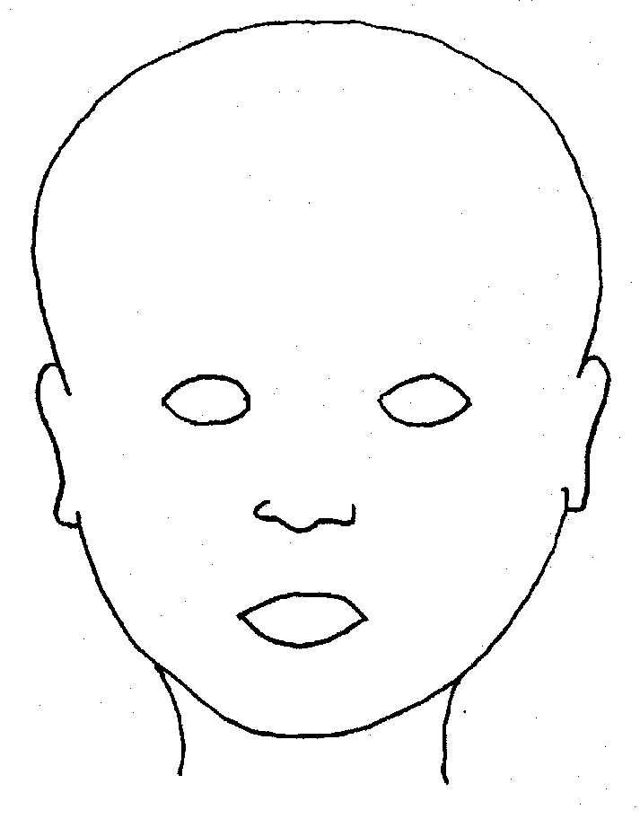 |  | 
FRONT |  | BACK
 |  | 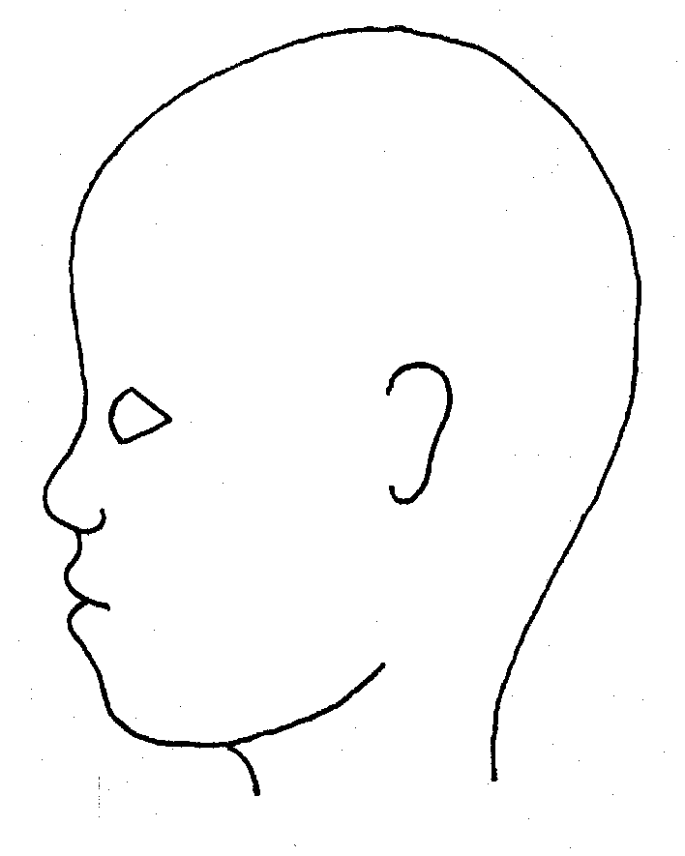
RIGHT |  | LEFT

Name of pupil: |  |  |  |  |  |  | Date and time of observation:
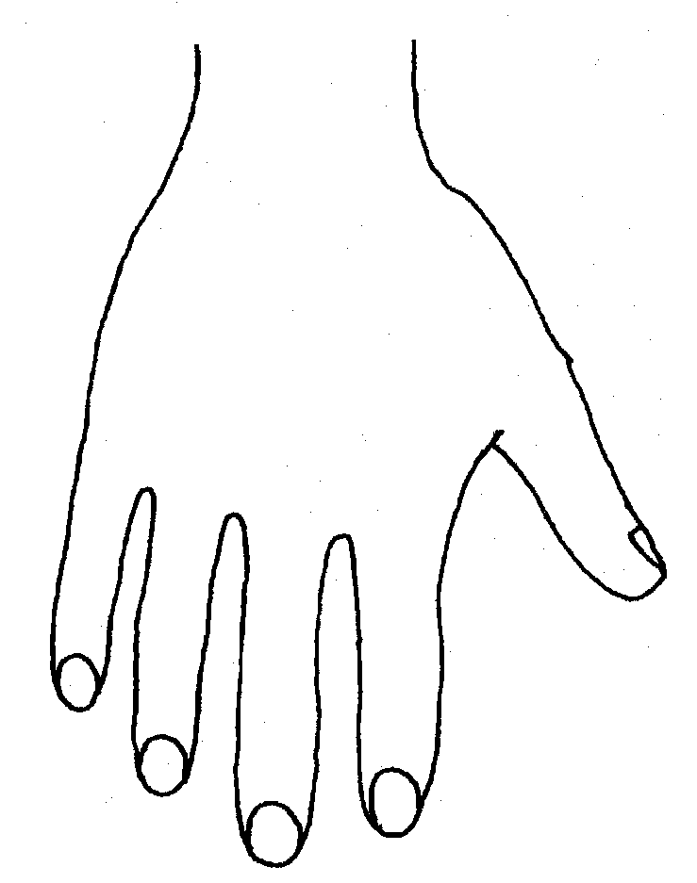 |  |  |  |  |  | 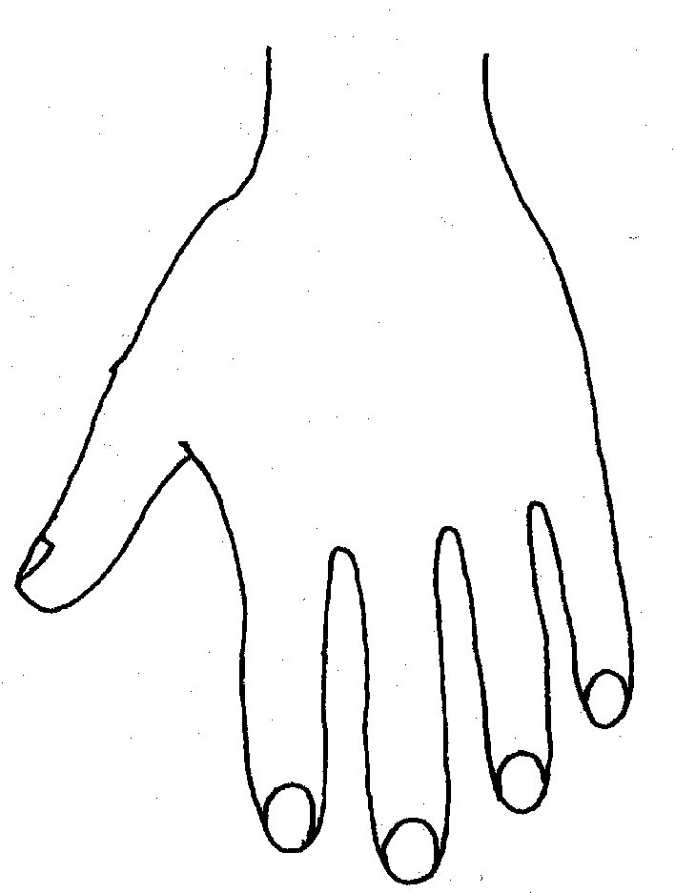
R |  |  |  |  |  | L
BACK
 |  |  |  |  |  | 
Name of Pupil: |  |  |  |  |  |  | Date and time of observation:
 |  |  |  |  | 
R | TOP |  |  | L | R |  |  | BOTTOM |  |  |  | L
 |  |  |  |  | 
R |  |  |  |  | L
INNER
 |  |  |  |  | 
R |  |  |  |  | L
OUTER
Printed Name, Signature and Job title of staff:

In maintained schools the governing body is responsible for ensuring their functions are exercised with a view to safeguarding and promoting the welfare of children in accordance with section 175 of the Education Act 2002, for pupil referral units it is the management committee, in independent schools, including academies and free schools, and 16-19 academies, this duty sits with the proprietor (in the case of academies the proprietor will be the academy trust). References to the governing body throughout this policy framework includes management committees.
Guidance on Low-Level Concerns may be a stand-alone policy or included within another policy e.g. Staff Code of Conduct
The governing body/proprietor may decide that for some roles should read additional parts of the guidance e.g. colleagues involved in safer recruitment administration including the maintenance of the single central record Safeguarding Governor should also read Part Three of KCSiE 2026.
Section 175, Education Act 2002 – for management committees of pupil referral units, this is by virtue of regulation 3 and paragraph 19A of Schedule 1 to the Education (Pupil Referral Units) (Application of Enactments) (England) Regulations 2007
Set out in paragraphs 87-94 of KCSiE
See LA explanatory note on the requirements around children having an appropriate adult Schools-StopSearch-v2.3.pdf (squarespace.com)
Whilst it is a matter for schools, based on their assessment, SCC and Suffolk Safeguarding Partnership take the view that it should only be those staff that do not have regular contact with children in school, e.g. cleaners who come in out of school hours, who are expected to only read Part One of KCSiE 2026.
UKCIS guidance: Sharing nudes and semi-nudes advice for education settings.
Under section 5B(11) (a) of the Female Genital Mutilation Act 2003, ‘teacher’ means, in relation to England, a person within section 141A(1) of the Education Act 2002 (persons employed or engaged to carry out teaching work at schools and other institutions in England)

